
Digicert RCA CPQ Solution Design Document

Document Control
Change Record

Date | Author | Version | Change Reference
Reviewers
Date | Name | Role
Approvers
Date | Name | Role

Index

Purpose
The Solution Design Document serves as the foundation for the Functional Design, Technical Design, and Test Case documents. It captures all relevant details discussed during the solution design readout sessions and will be used by the Technical and QA teams for development and testing activities.

The purpose of the Document is to:

- Outline Digicert’s needs for the RCA CPQ Implementation
- Provide a reference for the technical and Test Case documentation
- Create a documented and mutually agreed upon reference for both the Digicert and the Forsys project teams

Project Objectives
- Intuitive User Experience for both experienced and novice users
- Visibility for all relevant stakeholders to the latest state of a deal
- Increased sales efficiency, leading to a higher ROI on CPQ
- Enhance product setup using bundles, options, and attributes
- Enhance pricing setup by building attribute-based pricing
- Implement Salesforce RCA Asset-Based Ordering
- Implement Salesforce RCA Advanced Approvals
- Enhanced customer experience as they receive quick, accurate quotes
- Provide Train-the-Trainer Training and create Project Training Documents

Solution Details

3.1 Salesforce RCA Package details

RCA Package Details
The following packages are proposed for the Implementation:

Package Details | Version Number
Revenue Cloud Advanced (RCA) | Winter 26
OmniStudio | 258.6

3.2 End to End Process Flow(To-Be):

In Progress

3.3 Opportunity Management

User Story # | User Story Details
RCA-260 | As a RCA Admin, I want system to sync the Quote with Opportunity for key data elements to maintain consistency.
Acceptance Criteria | - As a Sales Rep, I want to be able to sync a quote created within the Opportunity once the quote is approved by clicking on ‘Sync to Opportunity' button.  - System can also initiate the sync automatically once an order is created on the quote object.  - All required fields (like quote line items data, proposal header data, pricing information etc.) should be updated back on the opportunity as part of the Opportunity sync.  - Opportunity Products should get refreshed with the latest Quote line items.  - The quote synced to the opportunity manually, or synced automatically post order creation will serve as the latest and greatest quote (similar to ‘Primary’ quote concept in Apttus).  - Any subsequent changes to the quote after manual sync will be also synced back to the opportunity.
Solution Summary | On the Quote object, Salesforce Revenue Cloud provides an out-of-the-box approach to sync quote line items to Opportunity Products.  - An Opportunity can have multiple Quote records created. However, an Opportunity can be synced with only one Quote.  - The Sales User should click on the “Start Sync” button manually from the Quote.  - The sync will continue to happen for any subsequent changes performed to the Quote after the sync has been initiated.  - If an Opportunity is already synced with one quote, the system will display a message when an attempt is made to enable sync with a different quote.  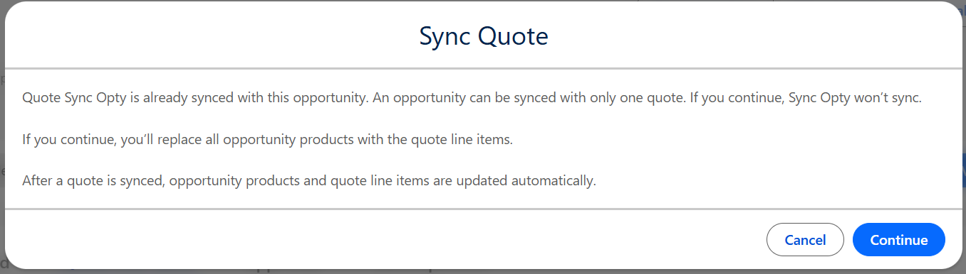  - Custom fields created on the Quote Line Item, if required on the Opportunity Products, must be created and synchronized.  - Once the sync is initiated, the field “Syncing”(read-only) will be enabled on the Quote record, identifying that the Quote record is the primary quote.  - The field “Syncing”on the quote need to be renamed as Primary.  - The button “Start Sync” on the quote should be renamed as “Make Primary”.  - Hide the button “Stop Sync” from the layout as initiating the sync from another quote will override the opportunity products.  - On creation of a first quote from an opportunity should always be marked as Primary. Later, the sales rep can make another quote as primary manually overriding the opportunity products with the latest synced quote.  - The opportunity field “SyncedQuoteId” need to be updated with the quote record id once the first quote is created.  - Whenever the sync is initiated, either manually or automatically, the custom fields from the quote line item should sync with opportunity products.  - An After-Save Record Triggered flow should be created on the quote line item object. The entry criteria will be as follows:  “The flow should run when the Quote Line Item is created or updated, AND only if the parent Quote is the Synced Quote on the Opportunity.”  - Maintain the twin fields on opportunity product and quote line item and update the opportunity product custom fields with the quote line item custom fields.

User Story # | User Story Details
RCA-264 | As an RCA Admin, I want renewal opportunities auto-created at contract close, ensuring that the renewal record carries forward the correct Account, Contact, Products, Pricing, and Ramping logic, so Sales Reps can efficiently manage renewals without manually recreating data.
Acceptance Criteria | As an RCA admin, I should be able to schedule the creation of renewal opportunities automatically.  - Renewal opportunities should be created automatically as soon as the 'New Logo' opportunity is closed (As-Is framework).  - All existing validations should continue to be triggered during renewal opportunity creation.  - The opportunity object and associated validations (if any) need to be run based on RCA objects
Solution Summary | In Salesforce Revenue Cloud, renewal opportunities are generated once an order is placed and activated. This process is facilitated by a pre-configured Salesforce flow that is included within the managed package.  Flow Name: “Create and Update Renewal Opportunities”  - As per the Digicert requirement, the renewal opportunity should be created when the opportunity is closed won.  - The renewal opportunity should cascade the opportunity products.  - The renewal quote should be created without any quote line items so that the sales rep will add the assets while renewing.

User Story # | User Story Details
RCA-255 | As a Sales Rep, I need Salesforce Quote related list associated with the Opportunity Record
Acceptance Criteria | - As a Sales Rep, I should be able to see a Quote Related List under each Opportunity record in RCA.  - The related list should display all Quotes linked to that Opportunity (1-to-many relationship).  - The related list should include key fields: Quote Number, Quote Name, Quote Status, Grand Total, Created Date, Primary (Y/N).  - The related list should update automatically when new quotes are created or existing quotes are deleted/updated.
Solution Summary | - Quotes related list to be added to the Opportunity Layouts.  - The Quotes related list will capture all the Quotes created for the Opportunity.  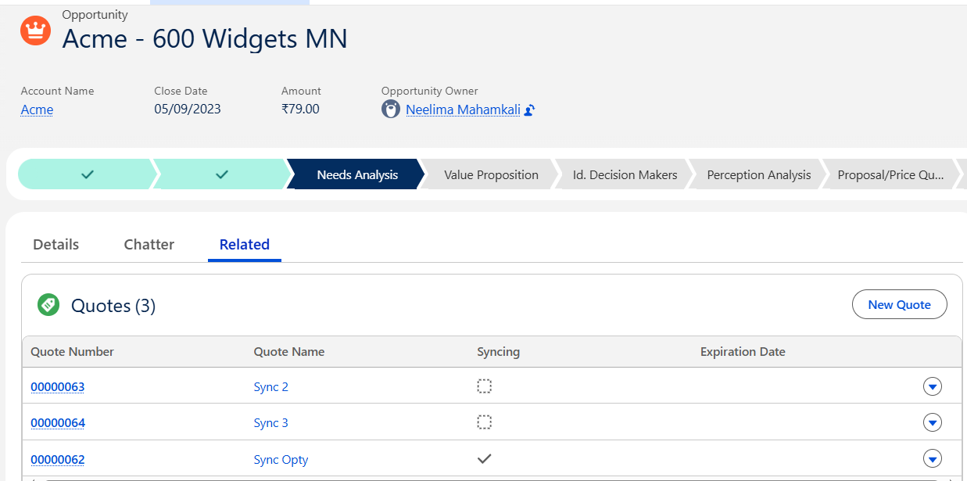  - Below set of fields should be added as a column fields in the Quote related list  - Quote Number  - Quote Name  - Status  - Grand Total  - Created Date  - Syncing

User Story # | User Story Details
RCA-376 | Primary/synced quote to be displayed on the opportunity header
RCA-256 | Opportunity Header : Synced quote ID to be displayed on the opportunity record
Acceptance Criteria | As a Sales Rep, I should be able to see the last synced Quote Number field displayed on the Opportunity Header section in RCA.
Solution Summary | - Today, the last synced Quote Id is stored in the field “SyncedQuoteId” on the Opportunity record.  - A formula field to be created on the Opportunity to fetch the Quote Name and add it to the Opportunity Layout.  - Field Name: Quote Name  - DataType: Formula

User Story # | User Story Details
RCA-257 | As a Sales Rep, I need to be able to create a quote from an opportunity.
Acceptance Criteria | - As a Sales Rep, I should be able to see a ‘Create Quote’ button enabled on the opportunity.  - The button should be enabled only after the record type value is selected by the user.
Solution Summary | - A custom button to be created on the opportunity.  - All the current conditions to be considered from their existing system to enable the button to create a quote object.  - On the quote record, the price list should be defaulted on the quote based on the currency on the opportunity.  - System should show a banner message on the quote record to select Contract Type, Quote Type and Deal Type. The message should be configured in the lightning app builder. Failed to select these values, Browse Catalog button should be hidden from the layout.

List of opportunity fields that should cascade from Opportunity to Quote:
https://digicert365-my.sharepoint.com/:x:/r/personal/connor_lawrence_digicert_com/_layouts/15/Doc.aspx?sourcedoc=%7B72F5A6C5-7447-4621-B8E7-22BFB7CFD5D2%7D&file=As%20Is%20Quote%20Set%20up.xlsx&action=default&mobileredirect=true

3.4 Product Management

User Story # | User Story Details
RCA-225 | As a product Admin, I want to use OOTB RCA functionality for Product Lifecycle Management at product level stages - Active, End of New Sale (EOS), End of Issuance/EOL, and Inactive, and to have only Active products visible to the customers and hide end-of-life/end-of-sales products from the catalog.
Acceptance Criteria | As a Product Admin, I should be able to manage the product lifecycle using RCA’s standard Product2 Object.  In general the product lifecycle must support the following stages:  - Active – Product is visible in the catalog and selectable for all quotes (New, Renewal, Amendment).  - End of New Sale (EOS) – Product is hidden for new sales but available for renewal or add-on quotes only.  - End of Issuance / End of Life (EOL) – Product no longer available for new or renewal quotes but retained for reporting and existing active contracts.  - Inactive – Product is completely retired, not available for selection, and hidden from all quoting and catalog views.  - I should be able to set Effective Date (product activation date) and Expiration Date (product deactivation date) directly on the Product record.  As a sales rep, I should be able to view only Active products in the catalog and -  - I should NOT be able to view any ‘Inactive’, or End-of-life products in any catalog in RCA.  - I should be only able to see ‘End of New Sale’ products for renewal quotes.
Solution Summary | On the Product2 object, relevant fields are available to maintain the product lifecycle requirement.  - Product Admin should be able to mark a product Active or Inactive from the product record. All active products will be visible during the New Logo, Expansion, Renewals/Amendments. If a product is marked inactive, the product will be hidden from all catalogs.  - EndOfLifeDate - End of Life products can be marked by providing the “End of Life Date” on the Product record.  - AvailabilityDate - The product availability can be defined by providing a valid date in this field. This field is utilized to make a product active on a future date.  - DiscontinuedDate - Any product that is the end of new sales, but still is needed for renewals, then this field should be populated.  Product Visibility Control via Qualification Rules:  - The above-mentioned fields should be used in the product Qualification Rules. RCA uses Qualification Rules (also known as Disqualification Rules) to dynamically filter the product catalog displayed to the user.  - EndOfLifeDate field on the product object should be used for End of Life products. In the qualification rule a condition to be included to exclude the product which matches with the date greater than or equal to today.  - End of life products should not be visible in new logo or in renewal quotes.  - DiscontinuedDate field on the product object should be repurposed for End of Sale products. In the qualification rule a condition to be included to exclude the product which matches with the date greater than or equal to today.  - End of sale products should not be visible in the new logo quotes however they should be visible in the renewal or amendment quotes.  - The quote type field on the quote object should be considered to determine the type of quote.

User Story # | User Story Details
RCA-224 | As an Admin, I want to setup/configure the consolidated SKU list received from DigiCert (merged from Apttus, NetSuite, and Vercara) into the Product catalog with all details such as product types,etc so that all required information is available.
Acceptance Criteria | I should set up all the required information/details for each SKU.  - Provide SKU details that need to be set up in the system-  - Finalized SKU list (active for quoting (new logo/renewals).  - Bundle vs Standalone SKUs  - Product options and option groups  - Product attribute groups, attribute type, and attribute values.  - Product catalog, category  - Same product across multiple catalogs and contract types.  - Same product as an option, as well as a standalone, based on contract type.
Solution Summary | - Based on the product structure provided by Digicert, the product configuration on the structure tab should be built.  - Bundle structure, attribute definition, product classification, product groups,..etc should be configured.  - All the bundle products should be created again in the Product2 object, as the Type field is a non-editable field, and for bundles, the bundle option within the Type field should be created. Hence, the existing bundle products should be marked inactive, and new records should be created.  - If the product references are maintained in the NetSuite or any downstream system, the new record ids information should be sent across beforehand.

User Story # | User Story Details
RCA-227 | As an RCA Admin, I want to configure Product Rules in RCA to automatically include, exclude, or validate products during quote creation based on Account Segment, Contract Type, Deal Type, and Customer Type, so that only compatible and relevant product combinations are allowed.
Acceptance Criteria | - As an RCA Admin, I should be able to define Product Rules (Inclusion, Exclusion, Validation) in RCA setup.  - As a Sales Rep, when I select a product from the catalog and configure it, the system should automatically:  - Add required dependent products (auto-inclusion).  - Restrict incompatible combinations (auto-exclusion).  - Log warning/errors on selection of options as per the constraint rules defined  - If conflicting products are selected, RCA should display an appropriate error message (“This product cannot be combined with X”).  - Rule evaluation should trigger dynamically during quote configuration
Solution Summary | - In Salesforce RCA, the product rules can be configured by using the Constraint Models.  - Using the out-of-the-box approach, product auto-inclusion, exclusion, and the validation messages can be shown to the sales rep while configuring the products in the quote.  - Below is the sample CML editor logic to auto-include, exclude, and show the validation messages in the cart.  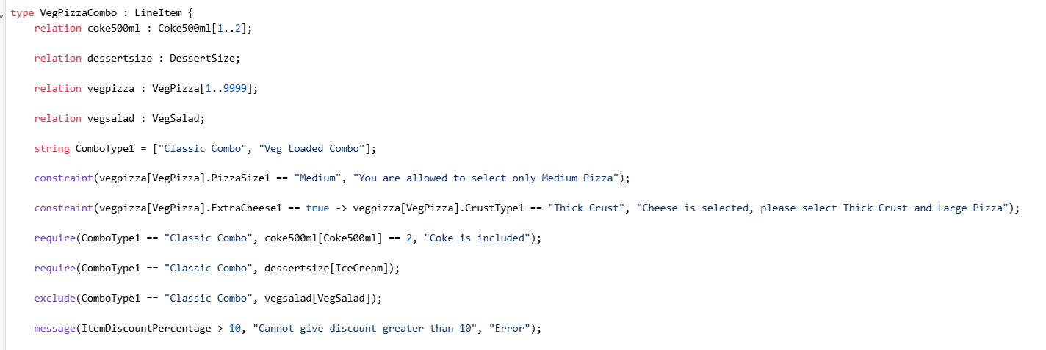  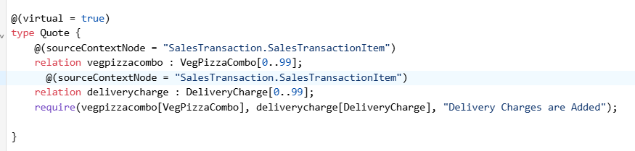

Constraint Rules:
Below file consists of all the constraint rules from the Digicert existing system. Please refer to column C for RCA approach that will be followed in the to-be system.

Digicert Constraint Rules

Please find the division of above constraint rules at a high level:
- Validation Messages - 55
- Auto-inclusions - 18
- Exclusions - 2

Attribute Rules:

Field Expressions:

User Story # | User Story Details
RCA-226 | As a Product Admin, I want to apply visibility rules using RCA qualification logic (Contract Type, Deal Type, Region) so only relevant SKUs appear for selection in catalog.
Acceptance Criteria | - As an RCA Admin, I need the system to automatically hide products for the reps on the quotes using product visibility rules based on contract type  - Based on the finalized SKU list shared by DigiCert, the only visibility rule to be enabled is based on the contract type.  - Existing visibility rules to be enabled and listed below the visibility rules to be enabled.  - Check Add Maintenance  - Direct and Current Rep = SSL Rep  - Indirect and Current Rep = SSL Rep  - Indirect and Current Rep = PKI Rep  - Direct and Current Rep = PKI Rep  - Direct and Current Rep = SSL Rep Credit Card Only  - Indirect and Current Rep = SSL Rep Credit Card Only  - MSP Hub Deal  - MSP Registered Deal
Solution Summary | - In addition to the above visibility rules that are captured from Digicert as-is implementation, there is one more product visibility rule that should be defined. Based on the “Contract Type” value selection on the quote, the products and categories should be hidden in the catalog. That means only qualified products should be visible in the browse catalog.  - Salesforce RCA uses Qualification Rules (also known as Disqualification Rules) to dynamically filter the product catalog displayed to the user.  - The approach for dynamically controlling Product and Category visibility in Salesforce RCA based on a custom field selection on the Quote leverages the Qualification Rules engine, which is executed by the Product Discovery process.  - This method ensures that when a sales rep makes a selection on the Quote (e.g., choosing a Contract Type), the product catalog immediately filters to show only relevant categories and products.  Process to show/hide product:  - Create the required fields on the product qualification or product disqualification object. It should contain the fields from quote and product fields.  - Use the existing decision table whose source object is set to product qualification.  - Provide the input and out fields and mark the fields as option or mandatory as required.  - Clone the existing context definition to map the quote and product fields.  - Create a qualification procedure to execute the output.  - Once the qualification procedure is activated, the qualified products will be visible in the product list page.  Process to show/hide catalog:  - To show a catalog based on contract type on the quote, create a similar field contract type on the catalog object.  - In the Discovery Products flow create a new version, add get records element and fetch the quote records with contract type values.  - Add an additional condition in the get catalog element to filter the records based on the contract value of catalog matches with the contract value on the quote. Please refer to the flow below and elements mentioned.  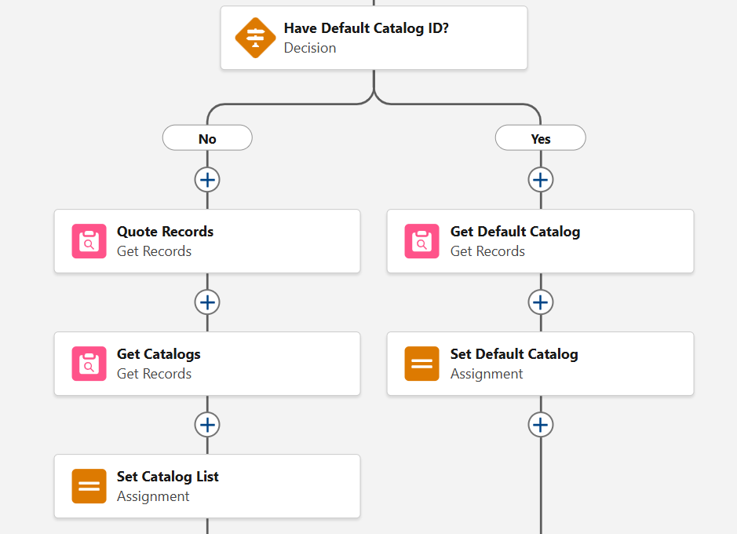

User Story # | User Story Details
RCA-221 | Ability to create/manage standalone SKUs in Salesforce RCA
Acceptance Criteria | - As an RCA Admin, I should be able to configure standalone Products in RCA under the Product Setup section.  - As a Sales Rep, I should be able to configure a standalone product from the catalog.
Solution Summary | - The Product Type field on the product record defines whether the product is a standalone(Product Type = Blank), a standalone configured product(Configure During Sale = Allowed), or a bundle product(Product Type = Bundle).  - Below are the list of fields and related records that are RCA specific and are mandatory for standalone products to provide as part of product configuration.  Product Fields:  - Product Record Type/Specification Type = Commercial  - Product Name  - Product Type = Blank  - Active = True  - Configure During Sale = Allowed (If configuration is needed)  - Though product family and product code are not mandatory it helps in segregation of type of product if the information is provided.  Product Related Records:  - A record to be created in the Categories  - A record to be created in the Product Selling Model Option  - A record to be created in the Price Book Entry  - Attributes can be associated to the standalone products if configuration is needed.  - The field ”Based on” on the product record will inherit the attributes and will be displayed in the Attributes tab on the product record as below:  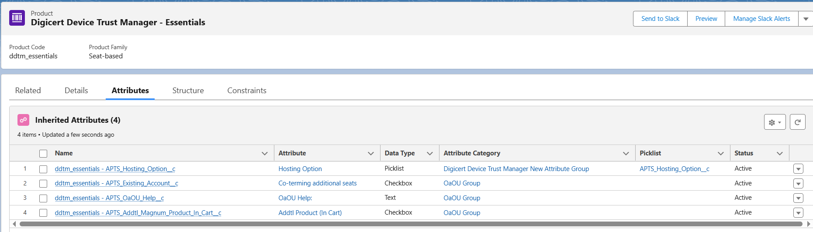

User Story # | User Story Details
RCA-234 | As an RCA Admin, I want to create and manage bundle products in RCA based on respective option groups and options/child components.
Acceptance Criteria | - As an RCA Admin, I should be able to configure Bundle Products in RCA under the Product Setup section.  - As a Sales Rep, when I select a bundle in the quote, the system should automatically display all related components.
Solution Summary | - Using out-of-the-box capabilities, RCA Admin should be able to define the bundle structure in Salesforce RCA, assign products, add product classification, product groups…etc  - Below are the list of fields and related records that are RCA specific and are mandatory for bundle products to provide as part of product configuration.  Product Fields:  - Product Record Type/Specification Type = Commercial  - Product Name  - Product Type = Bundle  - Active = True  - Configure During Sale = Allowed  - Though product family and product code are not mandatory it helps in segregation of type of product if the information is provided.  Product Related Records:  - A record to be created in the Categories  - A record to be created in the Product Selling Model Option  - A record to be created in the Price Book Entry  - For the option products under the bundle does not need category record association.  - On the product record the field “Sell only with other products” should be selected for option products if they are not allowed to sold separately.  - Structure tab on the product record is one place for all the bundle product configurations. The system allows creation group and option product association only for the products whose product type = bundle.  - The structure tab on the product record gives the capability to associate options under option group. Please find the structure layout below:  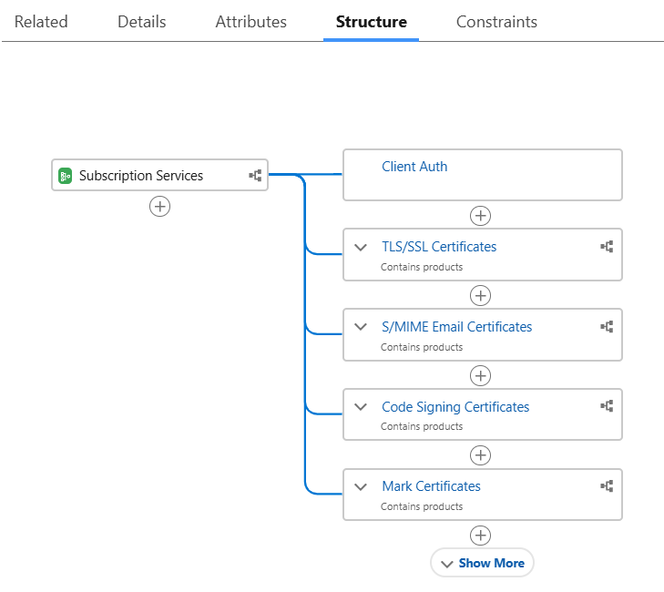  - As per the below screenshot, TLS/SSL Certificate represents group and the option products are associated to the group. The dotted line under a group represents that the option product selection is not mandatory.  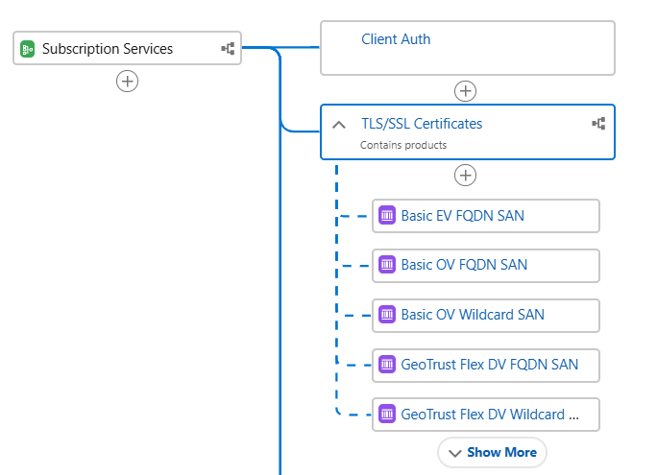  - The cardinality of the group and the options associated to the group can be set on the right side of the screen as shown below:  Group Cardinality:  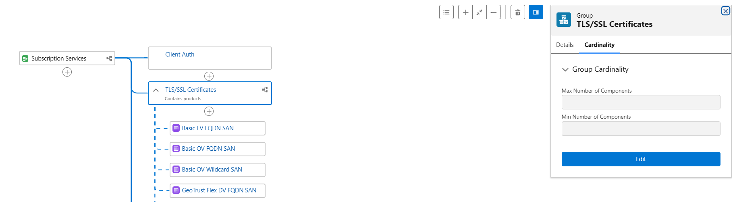  Option product Cardinality:  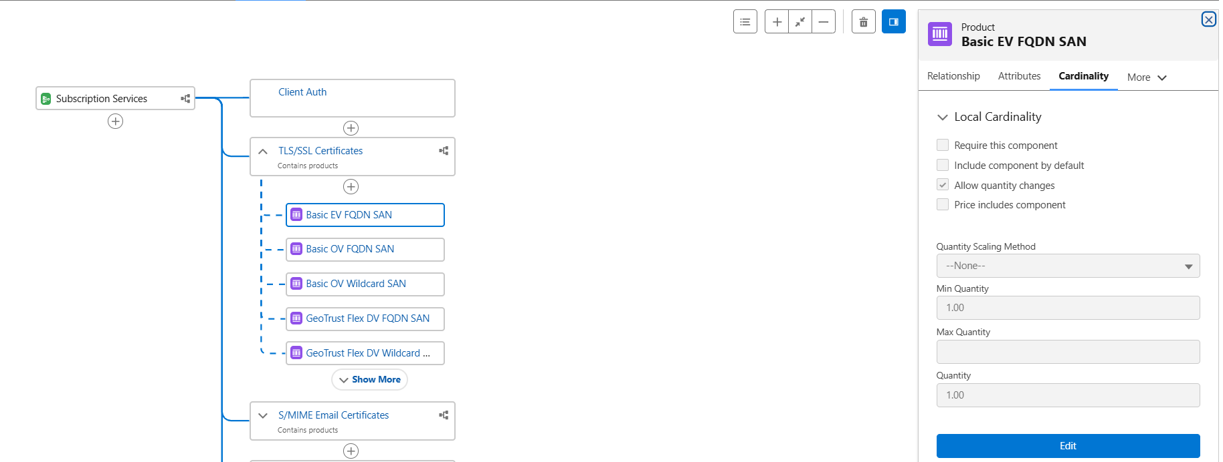  - The option product will have multiple tabs which shows the relationship to the group, attributes, bundle based adjustments if configured as shown below:  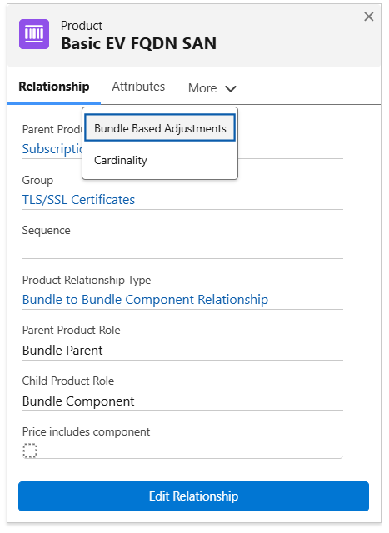  - As part of the RCA implementation, all the existing bundle product records are needed to be re-created as the Product Type field is set as blank for the existing bundles. Product Type is a non-editable field and the value should be set to Bundle to proceed with the product structure.  - Once configured, the Sales Rep will be able to add and configure the product as shown below:  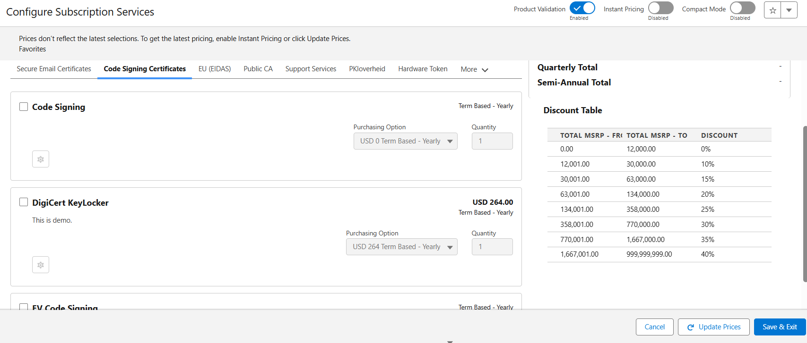

User Story # | User Story Details
RCA-180 | Migrate Apttus products to RCA using Rev Ramp tool
Acceptance Criteria | As a system user, I should be able to migrate the Apttus products into RCA objects.
Solution Summary | All master data will be migrated using RevRamp tool. Please find the migrated object details below:  - Products  - Product Group Components  - PriceBook  - PriceBookEntry  - AttributeBasedAdjustments

User Story # | User Story Details
RCA-245 | Show the relevant products on the catalogue page based on the selected opportunity contract type
Acceptance Criteria | - As a sales rep, I should be able to see the relevant products only on the specific catalog selected based on the quote contract type.  - All products should be part of a catalog.  - Each product catalog should be mapped to a specific contract type.  - Based on the contract type selection on the quote, the respective catalogs should be available to select from.  - One product can be mapped to multiple catalogs.  - Certain products to be setup across multiple catalogs to provide flexibility to the sales rep to select it based in respective sales plays.
Solution Summary | - Salesforce RCA uses Qualification Rules (also known as Disqualification Rules) to dynamically filter the product catalog displayed to the user.  - The approach for dynamically controlling Product and Category visibility in Salesforce RCA based on a custom field selection on the Quote leverages the Qualification Rules engine, which is executed by the Product Discovery process.  - This method ensures that when a sales rep makes a selection on the Quote (e.g., choosing a Contract Type), the product catalog immediately filters to show only relevant categories and products.  - Create the required fields on the product qualification or product disqualification object. It should contain the fields from quote and product fields.  - Use the existing decision table whose source object is set to product qualification.  - Provide the input and out fields and mark the fields as option or mandatory as required.  - Clone the existing context definition to map the quote and product fields.  - Create a qualification procedure to execute the output.  - Once the qualification procedure is activated, the qualified products will be visible in the product list page.  Note: The respective categories can be hidden by creating the records in the object Product Category Qualifications. The remaining steps are similar to the product qualification.  Solution approach to hide the catalog has been covered in the user story RCA-226.

User Story # | User Story Details
RCA-240 | Reps should be able to use the Default product configuration for common scenario's instead of reconfiguring everything again
Acceptance Criteria | As a sales rep, I should be able to add the product configuration as a favourtie for common scenario inorder to use for the future quote instead of re-configuring everything.
Solution Summary | - The Salesforce RCA "Favorite" functionality allows sales representatives to save a specific, configured product bundle or a set of options within a quote line to quickly apply them to future quotes. This drastically reduces repetitive configuration work.  Below set of configuration can be saved using the “Favorite” functionality:  - Selected Options: The exact combination of optional components chosen within the bundle.  - Attributes: The values input for any user-defined configuration attributes (e.g., memory size, deployment region, security level).  - Quantity: The quantity of the configured product itself (though quantities are often adjusted when applying the favorite).  - On any product, users can leverage the “Favorite” functionality by clicking on the icon as shown below and save as a new configuration.  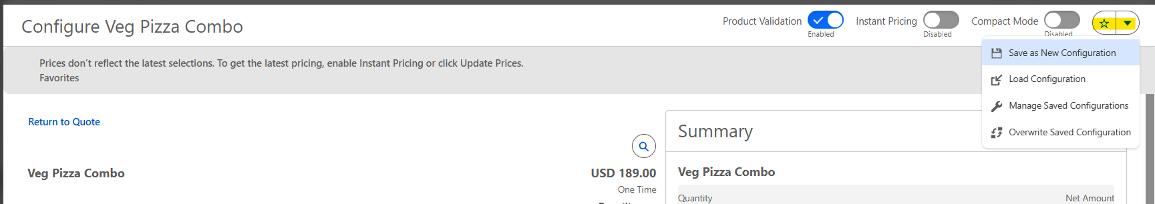  - When configuring the same product on a new Quote, the user can select “Load Configuration” and choose from a list of their saved favorites.  - Users can modify or delete the favorites by clicking on “Manage Saved Configuration”  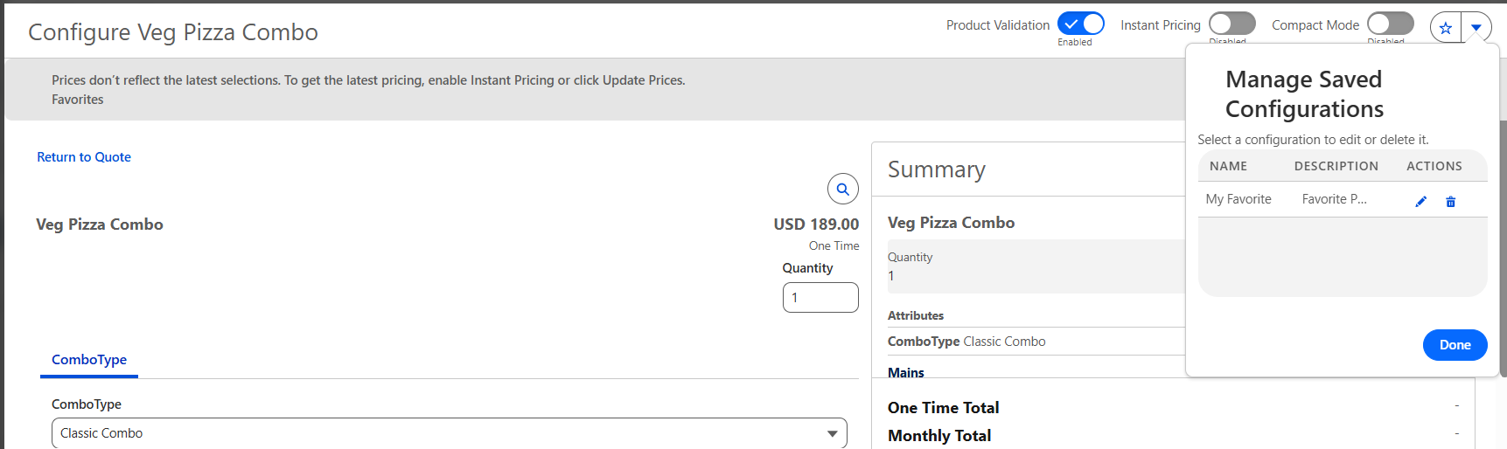

User Story # | User Story Details
RCA-238 | Reps should have the enhanced product search capabilities like weighted filtering, Attribute-based search, Type-ahead search functionality
Acceptance Criteria | - As a RCA Admin, I should be able to provide the enhanced search capabilities for the reps like weighted filtering, Attribute based search, Type-ahead search functionalities.  - Provide weighting to specific attributes to show a prioritized list of products as part of the search results in the catalog.  - Define attribute filter to be displayed on the catalog page based on the search results.  - As a Sales Rep, I should be able to see the relevant product list in the catalog based on the attribute search.  - I should also be able to further filter the products based on respective filters available in the catalog page.
Solution Summary | - Configure Searchable Data: Navigate to Product Discovery Settings and specify which fields and attributes should be indexed:  - Product Fields: Include standard fields (Name, Product Code, Description) and crucial custom fields.  - Product Attributes: Explicitly configure your dynamic attributes (e.g., Encryption_Type, Term_Length) as Searchable Fields to allow users to find products based on feature details.  - Rebuild the Index: After any changes to product data or attributes, execute a Full Index Rebuild from the Product Discovery Settings to ensure the search engine is using the most current, accurate data.  - As highlighted below, all searchable and filterable fields can be selected here which includes product fields and attributes. System allows a maximum of 25 fields.  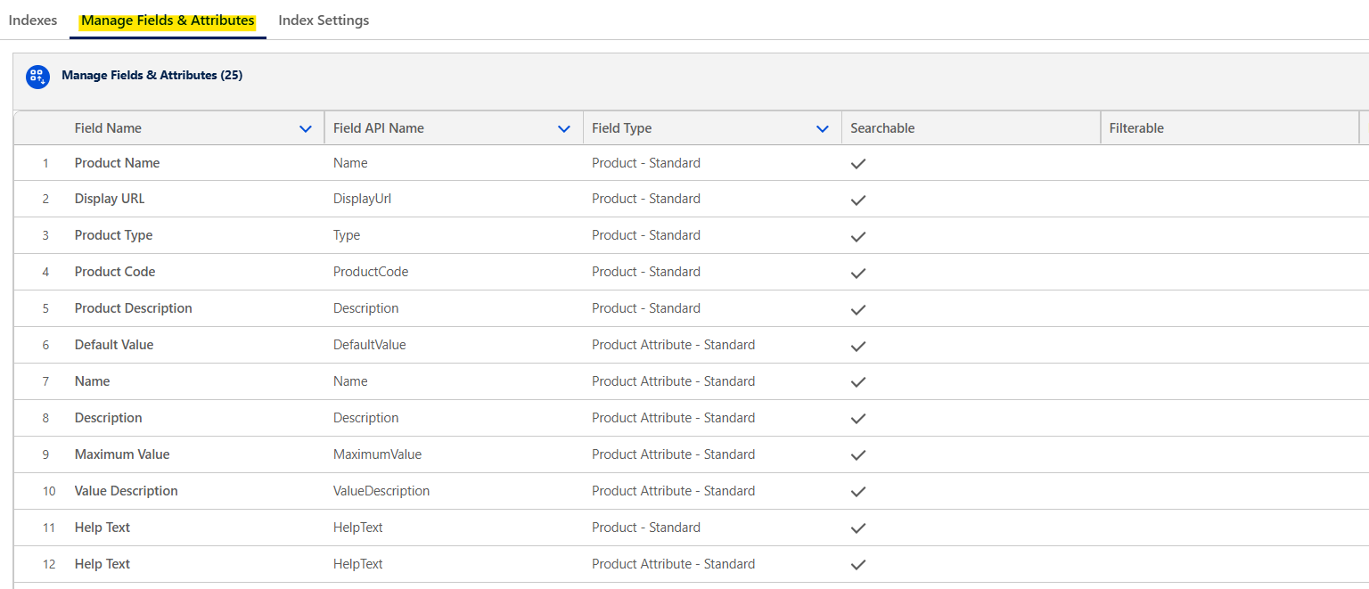  - If the fields are set as filterable, in the product list page, user will be able to further filter the products based on the attribute value.  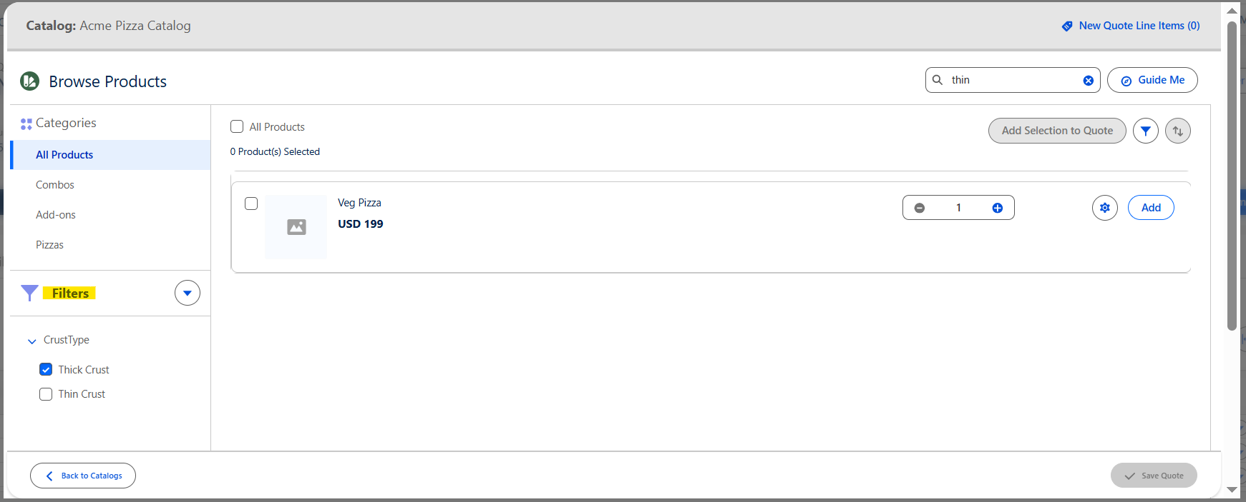

User Story # | User Story Details
RCA-252 | Product attribute groups and attributes setup
Acceptance Criteria | - As a Sales Rep, I should be able to select attributes within a product configuration to be able to configure the product correctly.  - Some attributes to be defaulted based on the defaulting rules.  - Users should be able to change the selection of attributes based on the options available.
Solution Summary | - Salesforce RCA provides the capability of creating attributes by using Attribute Definition.  - The Attribute Definition can be associated to the categories.  - The Attribute Definition will then be associated with the Product Classification.  - Each product record will have the field “Based On” to capture the product classification record. It will inherit the attributes to the product.  - One product can have only one Product Classification record associated.  - At each stage like at attribute definition, product classification or at product level the default value of attribute can be defined.  - Any changes done to the inherited attributes will be stored as a record in the Overridden Inherited Attributes.

User Story # | User Story Details
RCA-253 | Display 'Discount Table' on the quote/configuration for commit based dicounts.
Acceptance Criteria | - As a sales rep, I should be able to refer the commit based discounts for MSRP on the quote.  - Display the discount table with MSRP values for commit based discounts while quoting for 'subscription services'.  - This should only be displayed for ‘Subscription' contract type, and 'Subscription Services’ product.
Solution Summary | - In the product detail page of a Digicert bundle product, commit based discount table should be added to the layout.  - A button/link to be included in the layout, and on click, it should show the discount table to the sales user.  - A lightning web component to be created to display the discount table structure.  - The LWC component should be included in the “Default Product Configurator Flow”. Save this flow as a new version to incorporate the new layout changes.  - Please find the placement of the discount table in the sample screenshot below:  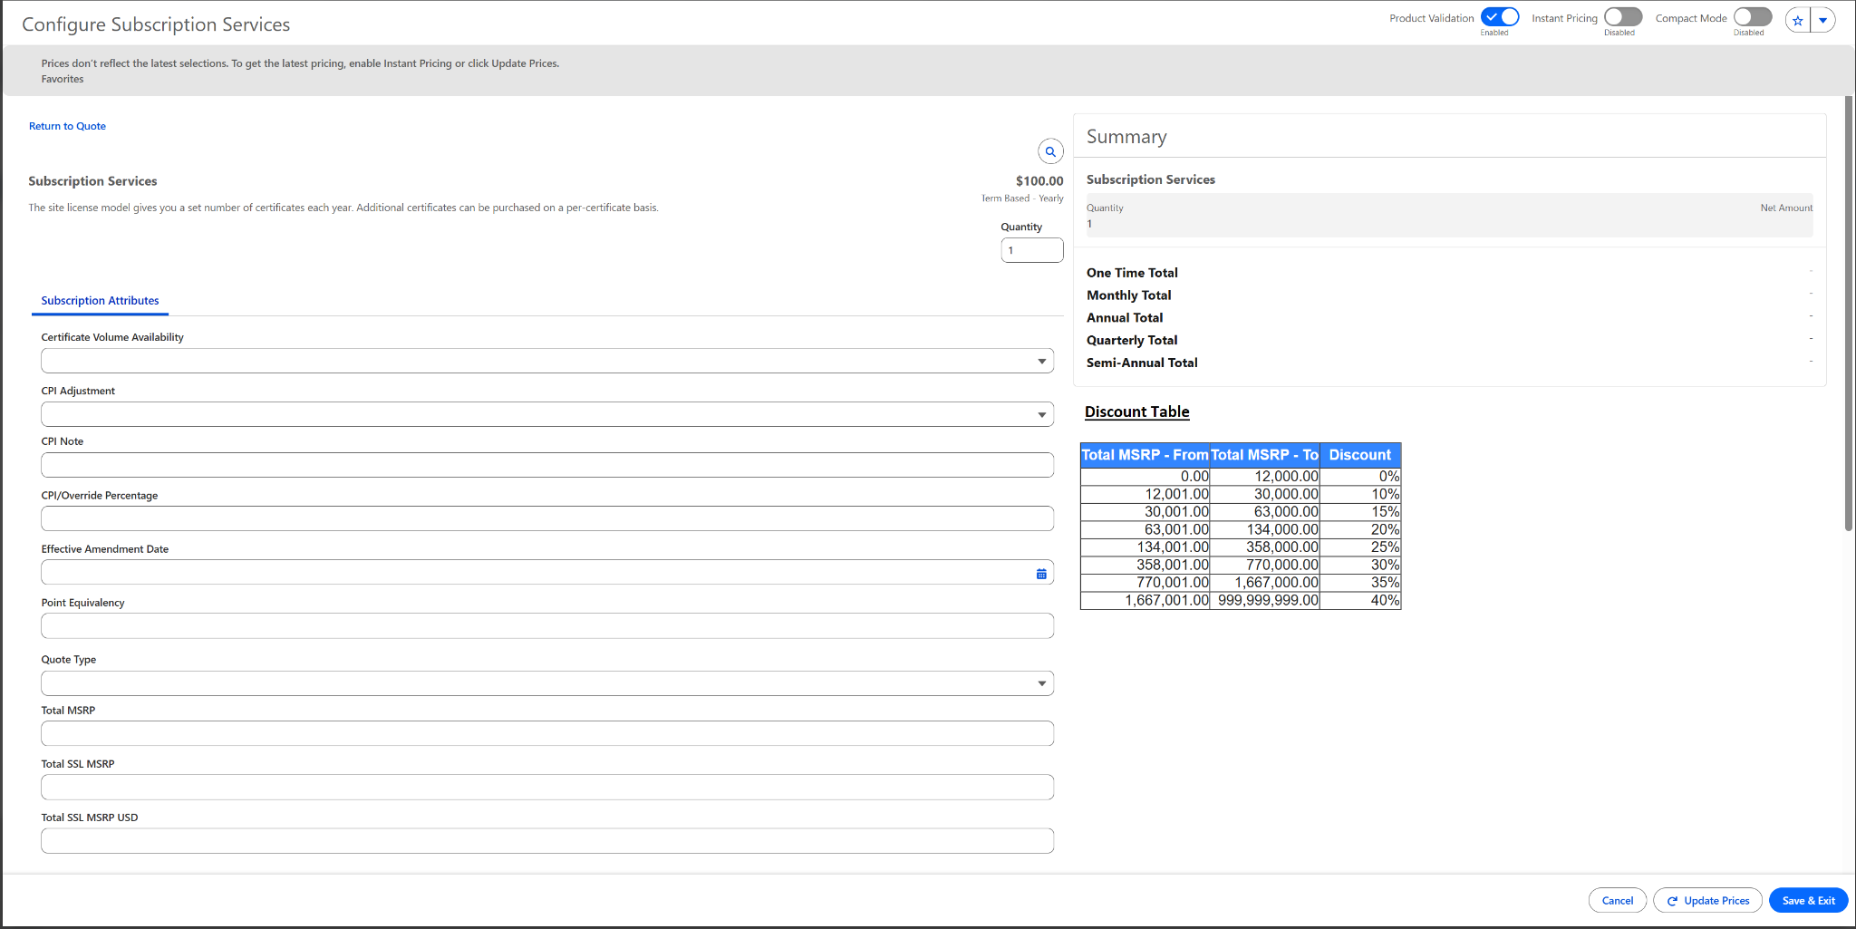

User Story # | User Story Details
RCA-249 | Only one support option to be added in the quote based on auto-inclusion and manual configuration by the user.
Acceptance Criteria | - As a Sales Rep, when quoting for subscription services and seat-based products, and adding a 'DigiCert support' SKU from the catalog,  - If Digicert support option is already added as an option as part of subscription services bundle, then system should consider only one support SKU per quote.  - There should be a warning/informational message displayed 'Only one support option is required per quote' - Message to be refined based on DigiCert's feedback.
Solution Summary | - Digicert bundle products have the support option group, and it has the support related products available.  - The support level of an account is captured in the field below on the account record  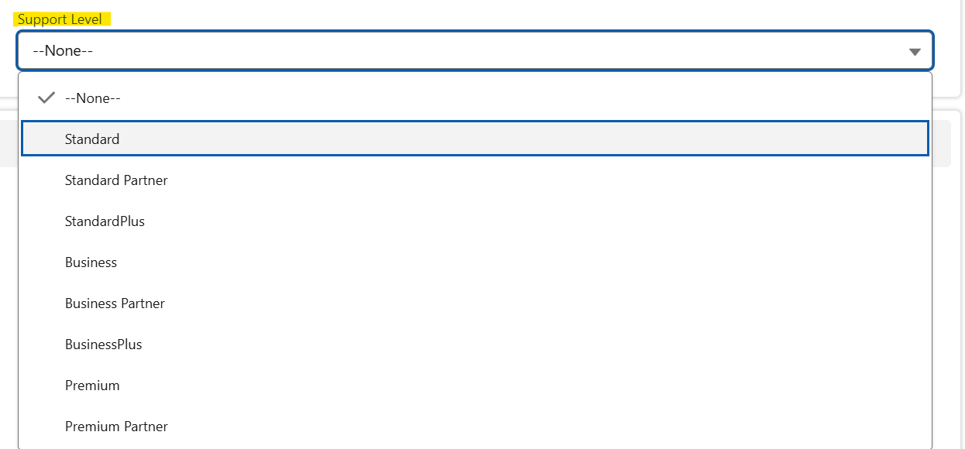  - Based on the support defined at the account level, the system should automatically add the relevant support product to the cart.  - The system should not allow adding multiple support products. However, the user can choose the support option apart from the one that is listed on the account record.  - If the support level on the account record is blank, the system should include the standard support by default.  - Inclusion of the support product automatically is achieved through the constraint model.  - The Preference Rule should be used to override the selected option.  - Please find the sample CML below to auto-include one option from an option group based on the bundle and support level field from Account.  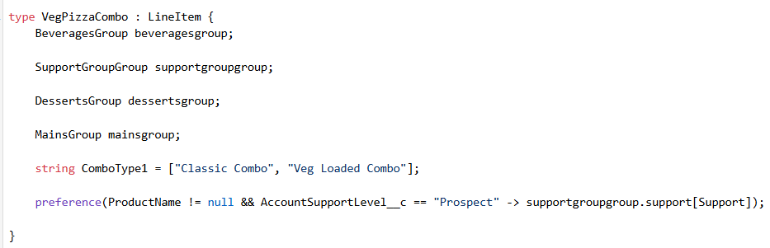  - A formula field needs to be created on the Quote object to capture the Support Level from the Account. The formula field is added as the Preference Rule expression condition.  - The support product should be included automatically for the seat-based product. Seat-based products are standalone products and the respective support product should be added separately. For any number of seat-based products added, there should be only one support product should be added automatically. Please find the sample logic to include a support product based on the addition of multiple standalone products.  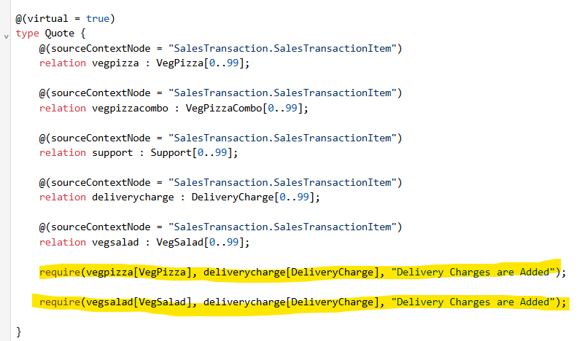

3.5 Pricing Management:

User Story # | User Story Details
RCA-361 | As a Sales Rep, I want to view a detailed price waterfall breakdown at the quote line item level so that I can understand how the final selling price is derived.
Acceptance Criteria | - As a sales rep, I should be able to see the detailed price waterfall with the price points like List price, Base price, system applied pric,e and manual adjustments  - As a Sales Rep, I can click “Calculation Details” to view the complete price breakdown.  - I can see key price points: List Price, Discounts (Volume/Partner), Net Price, and Total Price.  - Each discount shows the type, percentage, and amount applied.  - The system should display all intermediate price elements (such as List Price, Volume Discount, Partner Discount, System-Calculated Net Price, and Manual Adjustments ) in a clear, structured view
Solution Summary | - A detailed, interactive Price Waterfall to a sales rep in Salesforce Revenue Cloud Advanced is to leverage the platform's native Pricing Procedures and the built-in transparency features of the Transaction Line Editor (TLE) and its associated components.  - This is achieved primarily through the declarative setup of the Pricing Procedure and configuring its explainability features.  - The requirement of price waterfall and calculation details is met by exposing the results of the Pricing Procedure's execution steps directly to the user interface.  - Configure the Pricing Procedure:  - Ensure your active Pricing Procedure is set up to calculate and track every step explicitly.  - Sequence all Elements:  - Design your Pricing Procedure (Expression Set) to execute pricing in a logical sequence that matches the required waterfall (List Price → Volume Discount → Partner Discount → Manual Adjustment).  - Use Specific Elements:  - List Price: Use the Fetch List Price element to retrieve the base price.  - Discounts: Use distinct elements for each discount type (e.g., Volume-Based Rate Adjustment, Attribute-Based Adjustment for Partner Discount). This ensures each discount type is recorded separately.  - System Applied Price/Net Price: The net price is the cumulative result after all automatic discounts are applied, which the procedure calculates sequentially.  - Track Manual Adjustments:  - Ensure the procedure accounts for the manual adjustment input field on the line item. This value must be clearly subtracted or applied as the final adjustment step before calculating the total.  - The calculation details to view the complete price breakdown are taken care of by the system once the above pricing procedures have been set up. Please find the calculation details, which have the break-up for volume discounts and the final net unit price details below  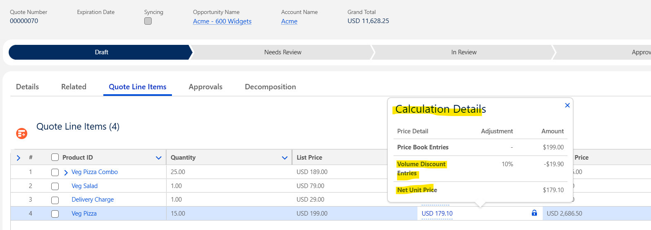

User Story # | User Story Details
RCA-359 | Ability to manage price rules based on Quantity, Duration, and product attributes
Acceptance Criteria | - As an RCA Admin, pricing rules need to be defined based on quantity, duration, and product attributes  - As an RCA Admin, I can define pricing rules using product attributes or custom configuration fields as conditions.  - I can set price adjustments or overrides based on those attribute values.  - I can define multiple attribute-based rules and set rule priority or stacking logic where multiple attributes match.  - As a sales Rep, when I can configure a product on a quote, the system automatically evaluates the selected attribute values and applies the relevant pricing rule.
Solution Summary | - The solution approach to define pricing rules based on Quantity, Duration, and Product Attributes in Salesforce Revenue Cloud Advanced (RCA) is to use Pricing Procedures orchestrated by Decision Tables and Price Adjustment Schedules.  This method is declarative and allows you to set priority, sequencing, and stacking logic for multiple conditions.  Prerequisites and Data Setup:  - Define Attributes: Ensure all variable characteristics driving pricing are set up as Product Attributes (e.g., Term). These attributes will be assigned to product classifications.  - Context Definition: Verify your active Sales Transaction Context Definition is extended to include all necessary input fields from the Quote, such as the attributes, quantity. This makes the data available to the pricing engine.  Implement Quantity- and Attribute-Based Rules:  - Rules based on quantity and attributes are often handled by dedicated schedules and adjustment elements.  Volume/Tiered Discounts (Quantity):  - Create a Price Adjustment Schedule record with a schedule type of Volume.  - Define the tiers or bands based on the Quantity field.  - Verify the Decision Table with the input and output fields defined.  - In the Pricing Procedure, use the Volume-Based Adjustment element, add the Decision Table to call this schedule, and apply discounts based on the quantity on the quote line.  Implement Attribute-Based Rules:  - Create a Price Adjustment Schedule record with the schedule type of Attribute.  - Define the attribute-based adjustments and verify the records in the Decision Table.  - Input Columns: Map input columns to your key Product Attributes (e.g., Term) from the Context Definition.  - Output Column: Define an output for the discount percentage (e.g., Attribute_Discount_Percent__c).  - Define Logic: Write rows of criteria (e.g., If Term = 1 Year, THEN set Discount = 10%).  - In the Pricing Procedure, use the Attribute-Based Adjustment element, add the Decision Table to call the schedule, and apply discounts based on the attribute value on the quote line.

User Story # | User Story Details
RCA-147 | This will allow Price Ramps to be defined and applied at the product level (through configuration settings in CPQ)
RCA-357 | As an RCA Admin, I want to enable automated ramp pricing for all products in the cart based on user intent (e.g., new sale, renewal, amendment) so that pricing adjusts automatically according to the deal type.
RCA-167 | For multi-year deals, Reps should be able to ramp the pricing with discounts per year
RCA-313 | Ability to allow the Reps to create a quote with zero pricing during the trail periods
Solution Summary | - In Salesforce RCA, the product ramp segments are defined on the product2 record with the Selling Model of Term-Defined, and then instantiated on the Quote Line Item during the product configuration process in the Transaction Line Editor (TLE).  - Salesforce RCA allows the creation of the ramp segments for only simple products. Bundle product ramp segments to be defined on the Quote Line Item during the product configuration process in the Transaction Line Editor (TLE).  - The product selling model for the eligible products should be Term Defined to generate the product ramp segments.  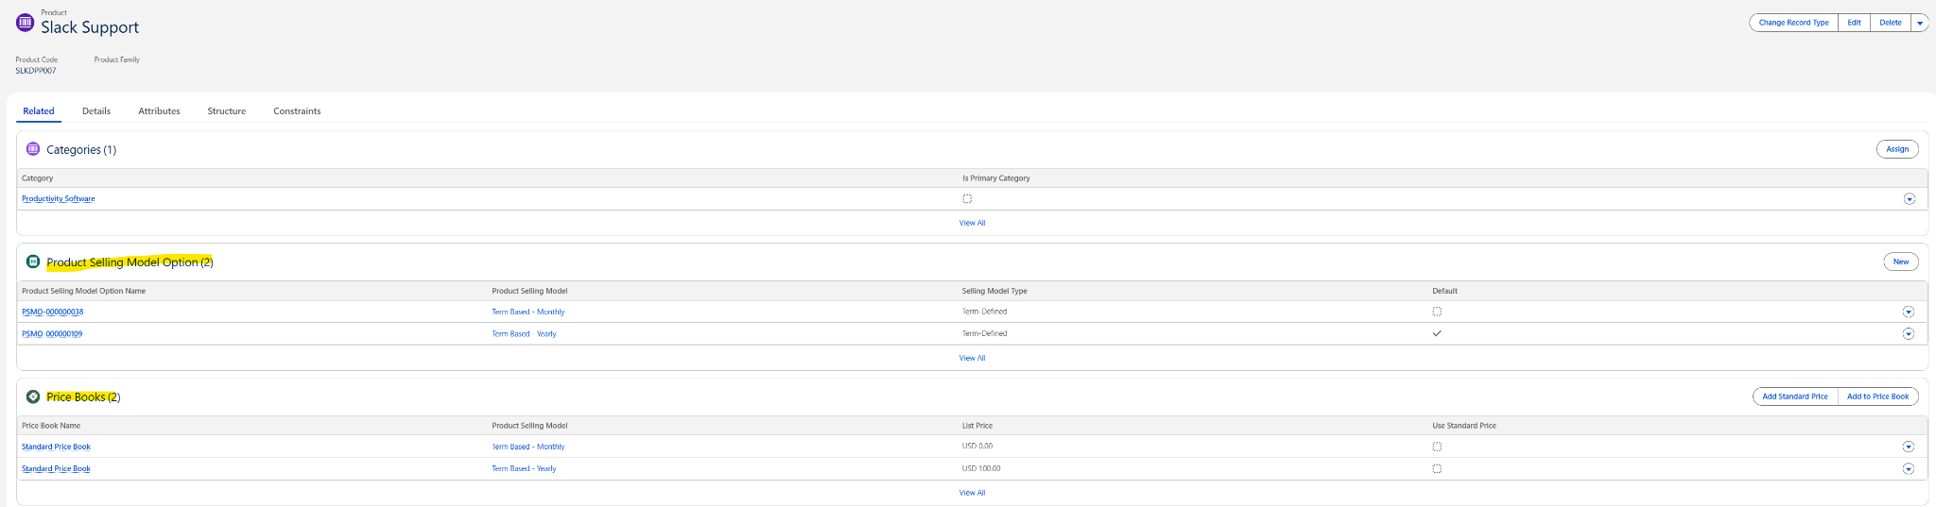  - The ramp segments at product2 record to be defined as shown below. If free trail ramp segment is added at the product level with the duration defined, then the system will allow to add free trail segment in the transaction line editor.  - Once the product is configured, in the transaction line editor there will be an option available to generate the ramps  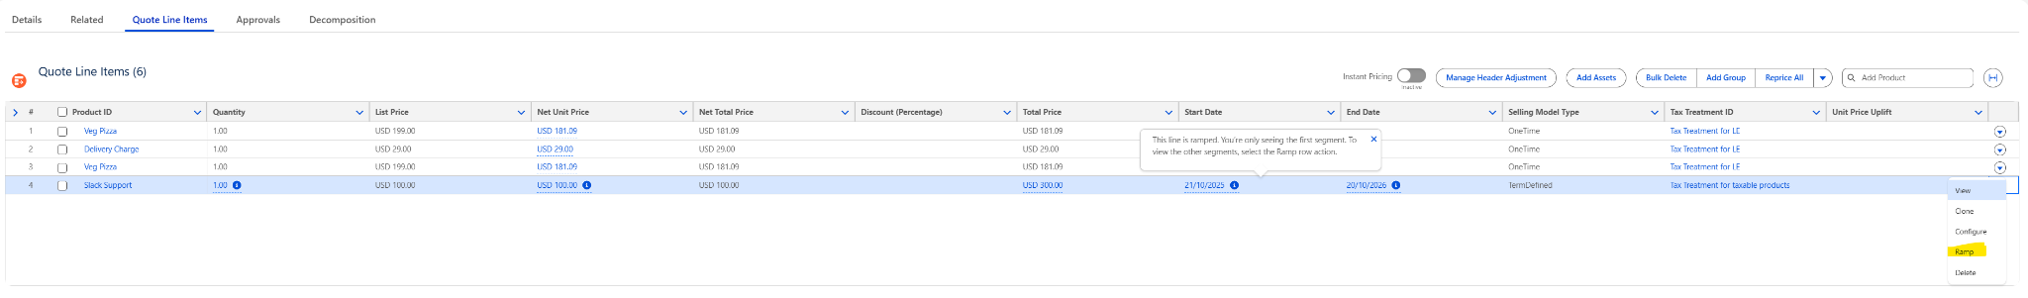  - The ramp segments can be defined as below  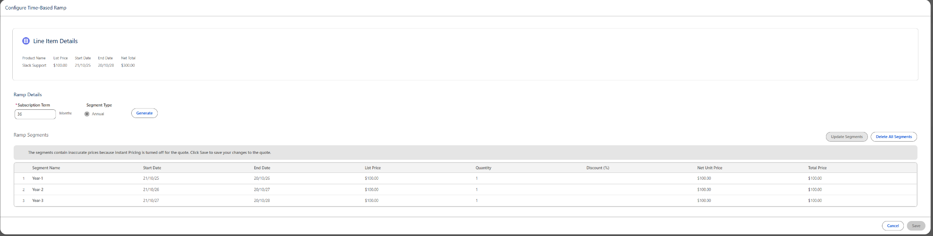  - If free trail is set up, sales rep can select the trail while creating ramp segments.  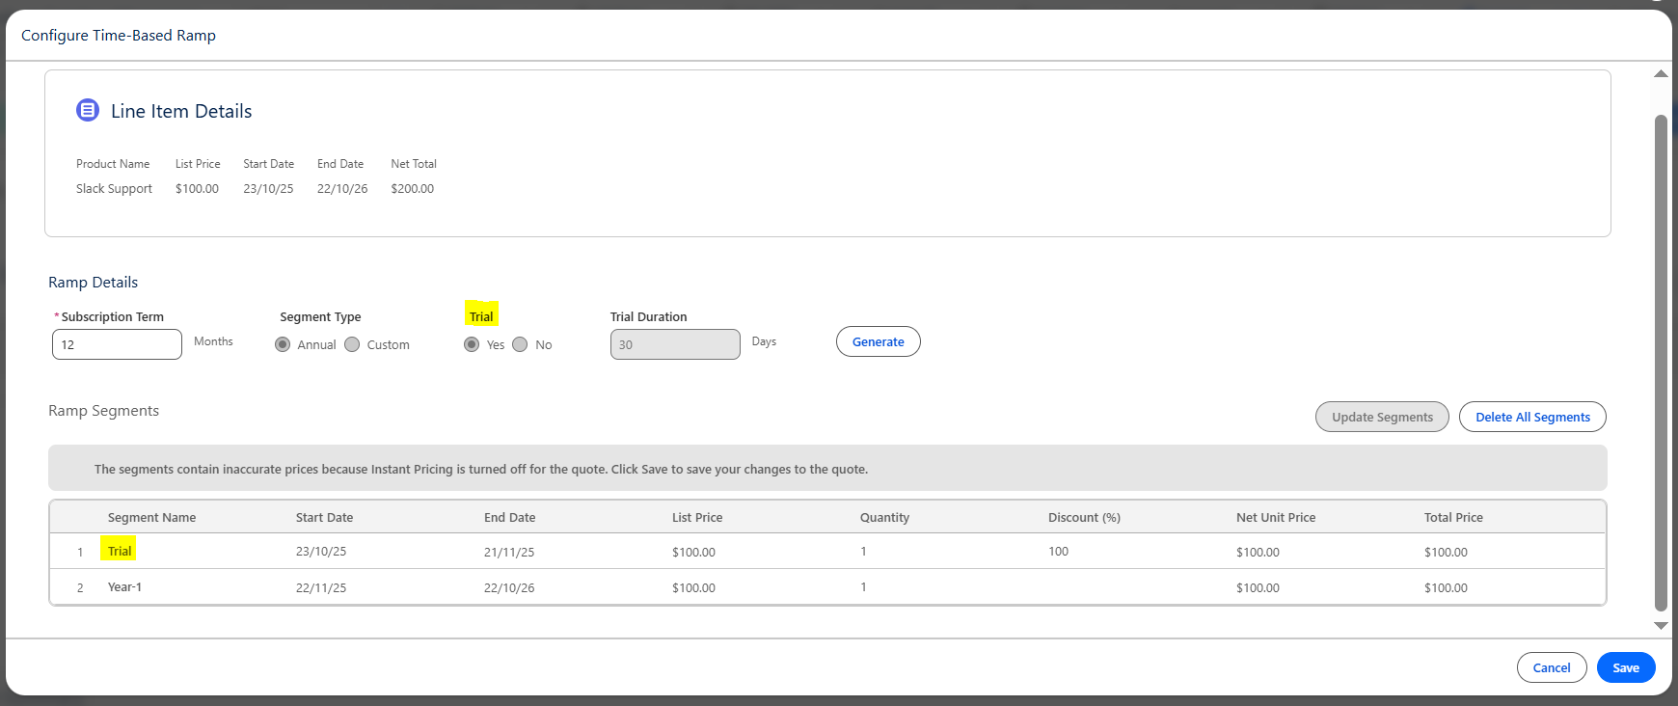  - Once ramp segments are generated, the system applies the Ramp automatically to the Quote Lines.  - The sales rep can set discounts at each ramp segment.

User Story # | User Story Details
RCA-149 | As an RCA Admin, I want to configure automated volume discount rules that apply to all products within specific product families, so that consistent MSRP-based discounts are applied across related products on a quote.
Acceptance Criteria | - As an RCA Admin, I should be able to configure the discount rules at both the Product Family and Product Level.  - I should be able to apply MSRP-based discounts automatically to all products within a selected product family.  - I can ensure that the system applies the correct discount automatically based on the configured logic.  - I can view all applied discounts in the quote and in the price waterfall.
Solution Summary | - Configuring a Volume-Based Discount in Salesforce Revenue Cloud Advanced (RCA) is achieved declaratively using a Price Adjustment Schedule and integrating it into your active Pricing Procedure via a dedicated element.  Here is the step-by-step process to be followed by the RCA Admin:  - Create the new price adjustment schedule from the price adjustment schedule object and set the schedule type to volume.  - Define the price adjustment tiers based on quantity (volume) within the price adjust schedule.  Please find the sample discount tiers: On the related list for the new schedule, create the specific tiers:  Tier 1: Lower Bound = 1, Upper Bound = 80, Discount % = 5%  Tier 2: Lower Bound = 81, Upper Bound = 119, Discount % = 10%  Tier 3: Lower Bound = 120, Upper Bound = [Leave blank for open-ended], Discount % = 15%  - Activate: Ensure the Price Adjustment Schedule record is active.  - Create a lookup table referring to the source object as the price adjustment tier. Map the input and output fields.  - Verify that the price adjustment tiers records are reflected in the lookup table.  - Integrate the price adjustment schedule into the Pricing Procedure by adding a volume-based element.  - Activate the procedure.  - When the quantity of a line item meets the threshold defined, then volume based discounts will be applied as shown below to derive the actual net unit price:  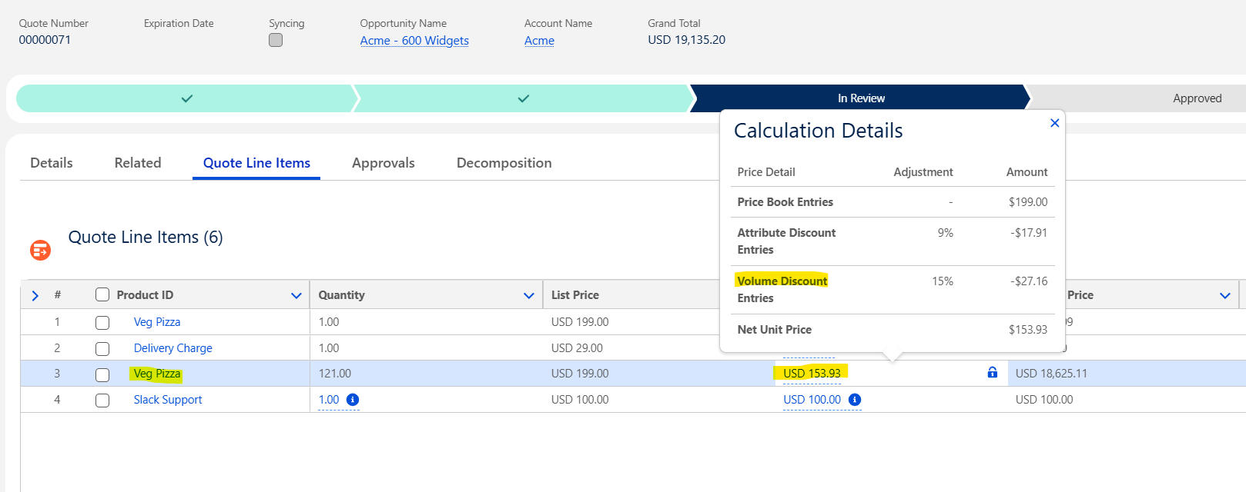

User Story # | User Story Details
RCA-308 | As an RCA Admin, I want to configure volume-based discount rules that apply at the line item level, so that discounts are automatically calculated based on the quantity entered for each product.
RCA-348 | Commit Discounts (on MSRP ) - Configure Volume Discounts Based on MSRP at Product Family Level
RCA-306 | As an RCA Admin, I want to configure and manage partner discounts based on the partner account or tier, so that the correct reseller or deal-based discounts are applied automatically on quotes.
RCA-305 | Ability to have multiple price adjustments e.g. % discount, absolute discount, price override, Uplift, etc.
RCA-322 | Enable pricing based on price type (Tiered, related pricing, list price etc.)
RCA-356 | Configure Pricing discount rules that apply to all Products within a Product Family-Ensure that the system can intelligently prioritize which Discount to apply in case Both Levels are defined
Solution Summary | The price calculation in Salesforce Revenue Cloud Advanced is a sequential process governed by the Pricing Procedure, which is an Expression Set that acts as a declarative price waterfall. The Pricing Procedure executes a defined sequence of steps for every line item on a Quote. The process is transparent and ensures all logic is applied correctly and in order.  Volume-Based Discounts:  - Please refer to the user story RCA-149 for the step by step configuration of volume-based discount.  - Any quantity-based or volume-based scenarios should be configured by adding the volume-based element in the pricing procedure.  Derived Price:  - The Derived Price element in the Salesforce Revenue Cloud Advanced Pricing Procedure is a feature used to calculate a product's price (or a price component) based on the value of another related asset or product in the transaction.  - The derived pricing should be enabled at price book entry level.  - Identify the source and target products to evaluate the target product price by applying formula. example →Target Product Price = Source Product Net Price x $10%  Attribute-Based Discounts:  - Any rule that has attribute-specific discounts can be achieved by using the attribute-specific element that is provided in the pricing procedure.  - Create or use the existing pricing price adjustment schedule by defining the following set of information  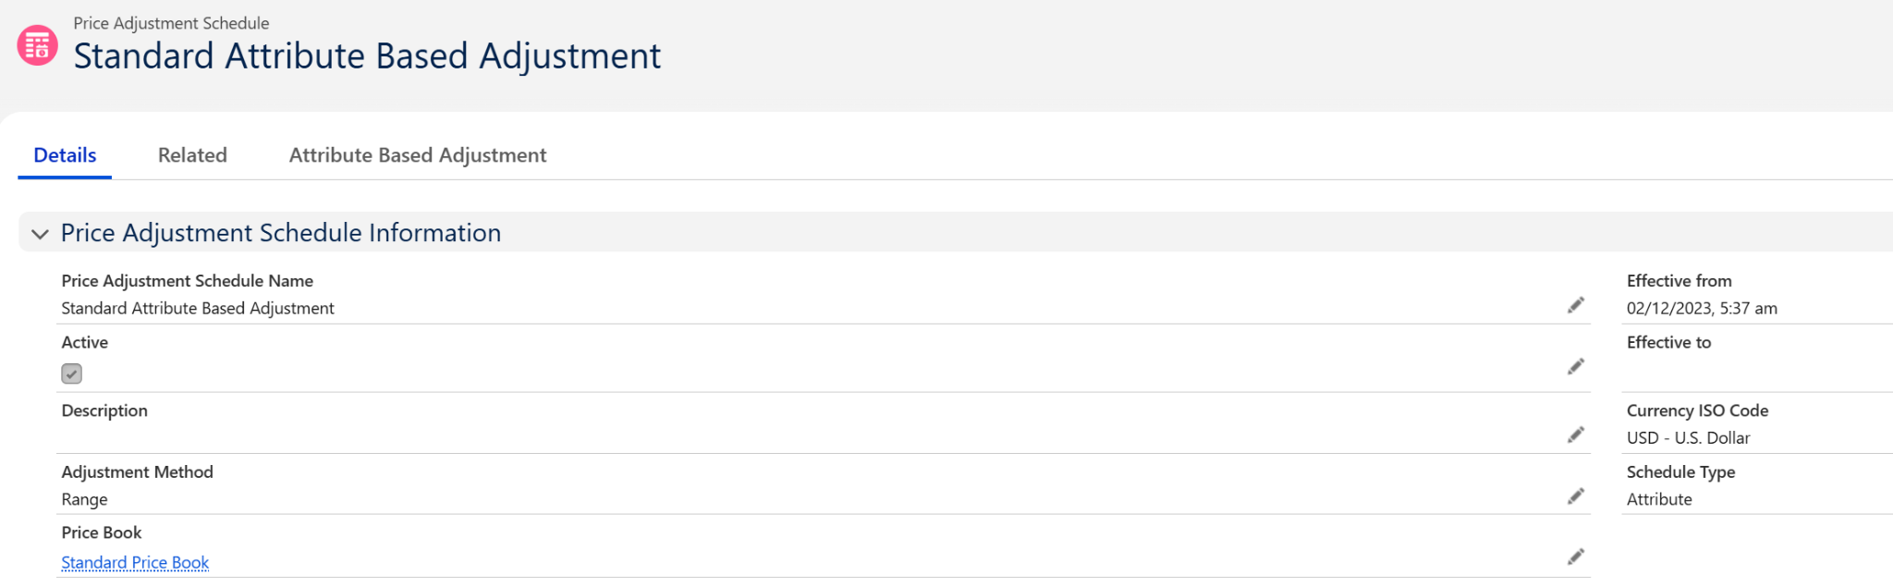  - Create an entry in the attribute-based adjustment tab to define the following set of information  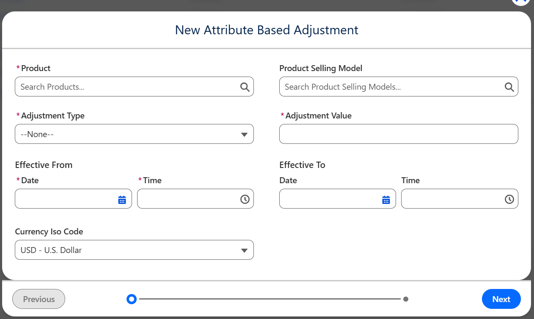  - On the click of “Next” the system will ask for the attribute and its value  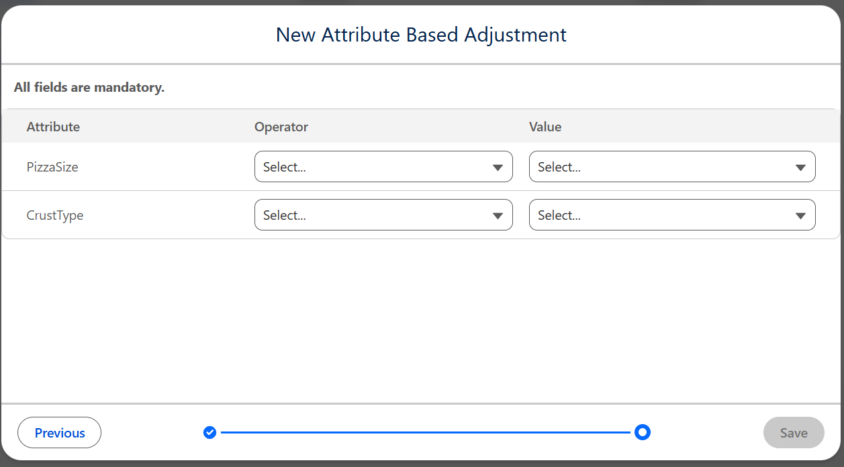  - Once the records are created, refresh the decision table “Attribute Discount Entries”  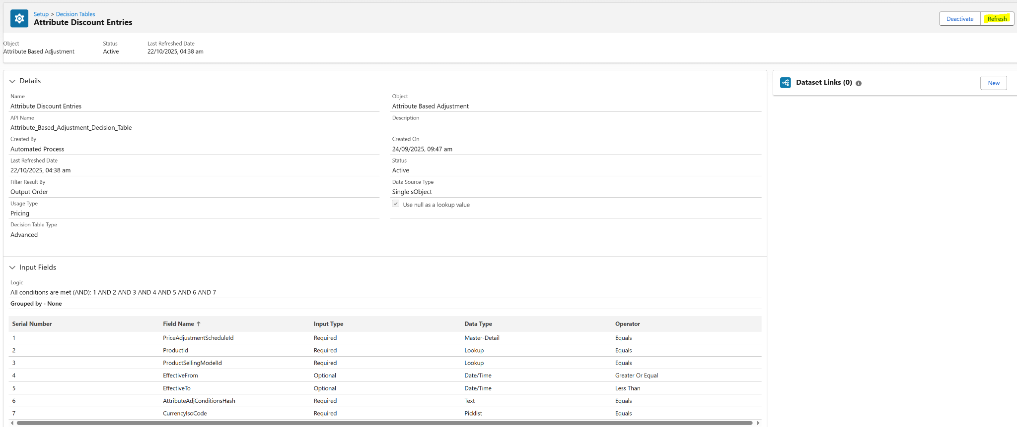  - Create or use a pricing procedure to add the attribute-based price element and enter the details in the element as below  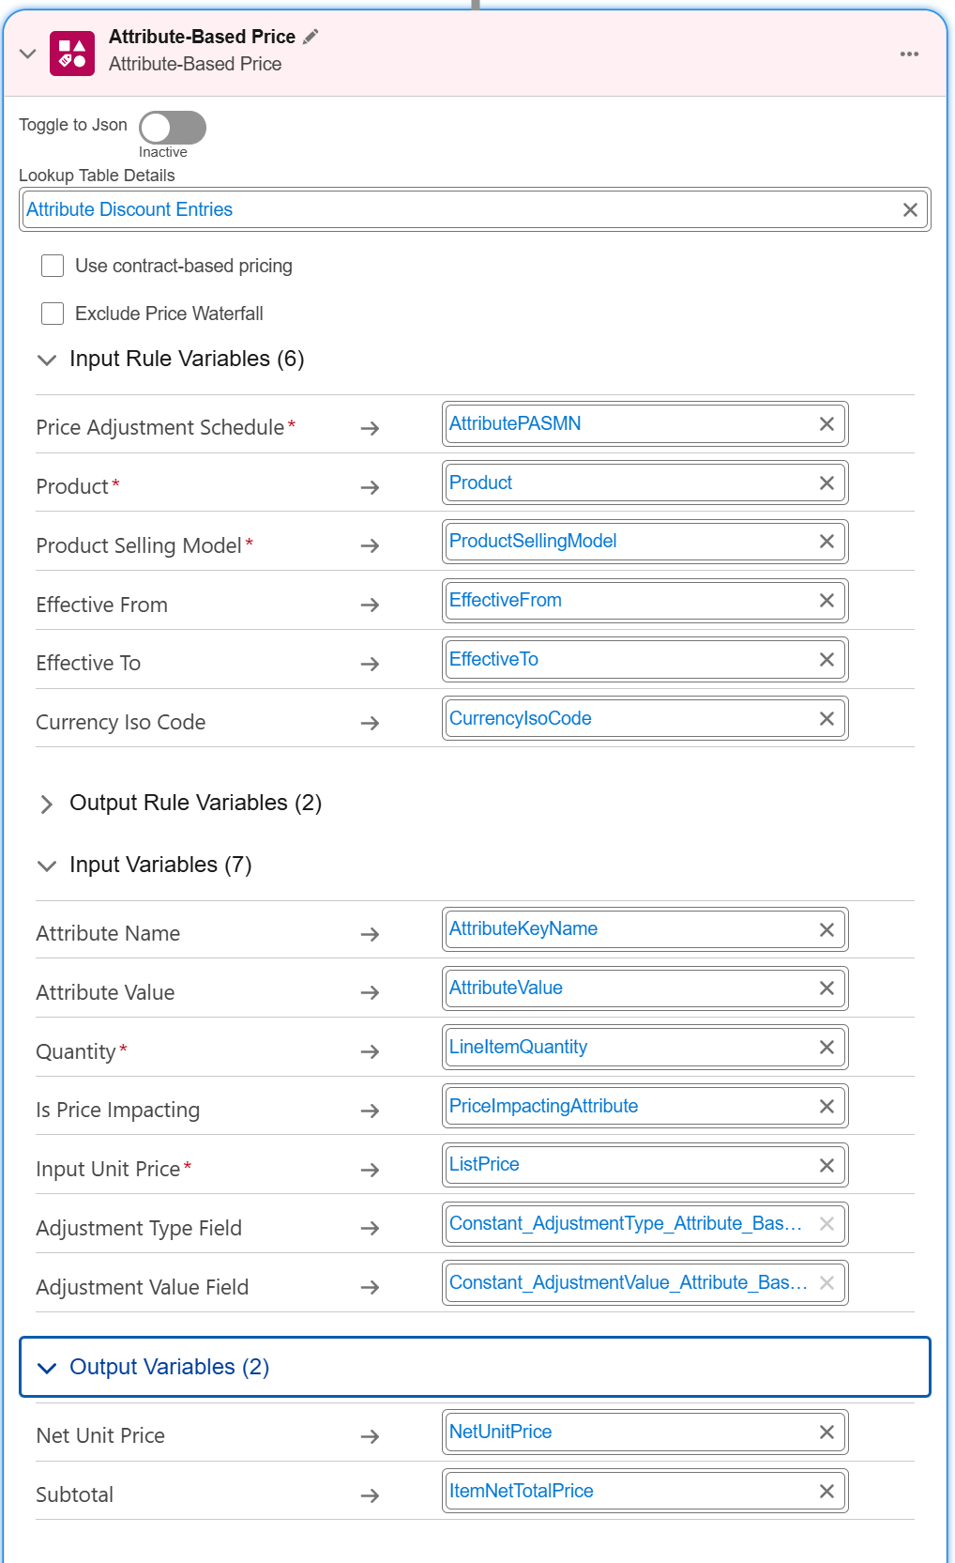  - Save and activate the pricing procedure and verify the discounts in the quote.  Price Adjustment Matrix:  - The Price Adjustment Matrix in Salesforce Revenue Cloud Advanced is used to define complex, multi-dimensional pricing rules and apply dynamic discounts or price overrides based on multiple intersecting criteria. It is one of the core elements used within a Pricing Procedure.  - Digicert has Commit discounts, price rulesets, and price matrices which has a combination of attributes, product families, and line item quantity as the input parameter to get the desired discount. Such scenarios are to be configured in the Price Adjustment Matrix.  - Create a custom object and create fields which should cover the input parameters and output parameters that are needed to evaluate the discount.  - Create a Price Adjustment Schedule of type Custom.  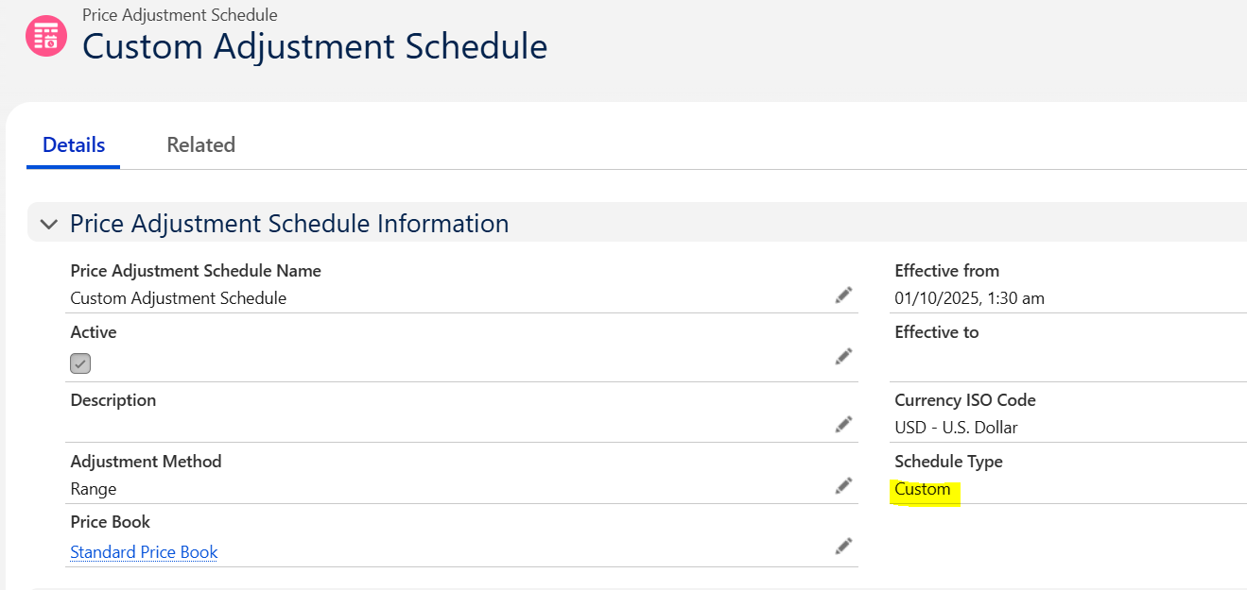  - Create a look up table with the source object referring to the custom object.  - Provide the input and output parameters. Verify for the records synced from the custom object.  - Activate the lookup table.  - Add the lookup table to the pricing recipe.  - Create the pricing procedure and add the price adjustment matrix element and provide the input and out variables. Save and activate the procedure.  Manual Adjustment:  - The Manual Adjustment element in the Salesforce Revenue Cloud Advanced Pricing Procedure is a necessary component used to apply discretionary discounts or markups directly entered by the sales representative on the quote line.  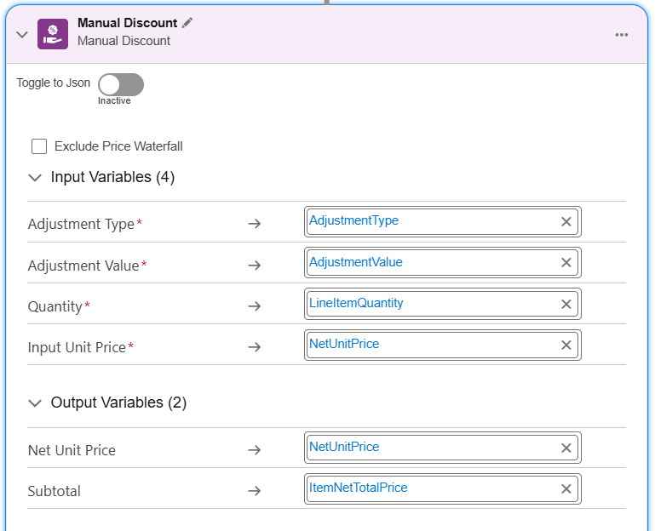  - The element should be added in the last to act as an override on the final net price calculated after all automatic system rules have run. This is often the required behavior to give the sales rep the final control over the price.

Price Adjustment Matrix Scenario:
Please find the Digicert Price Matrix scenario replicated in Salesforce RCA:
Condition: When Attribute value of “Additional CA Type” = “Matter Compliant Recurring” and Quantity = 1, Listprice override = 35000 USD
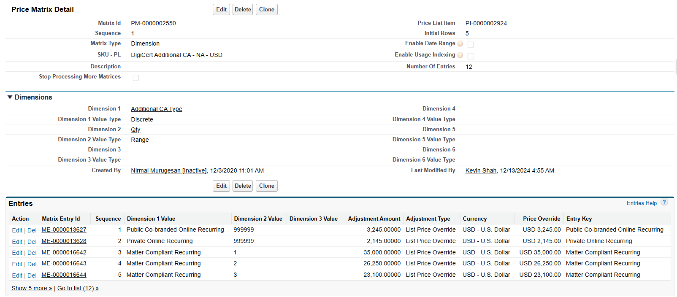
- Created a custom price adjustment schedule with schedule type = custom.
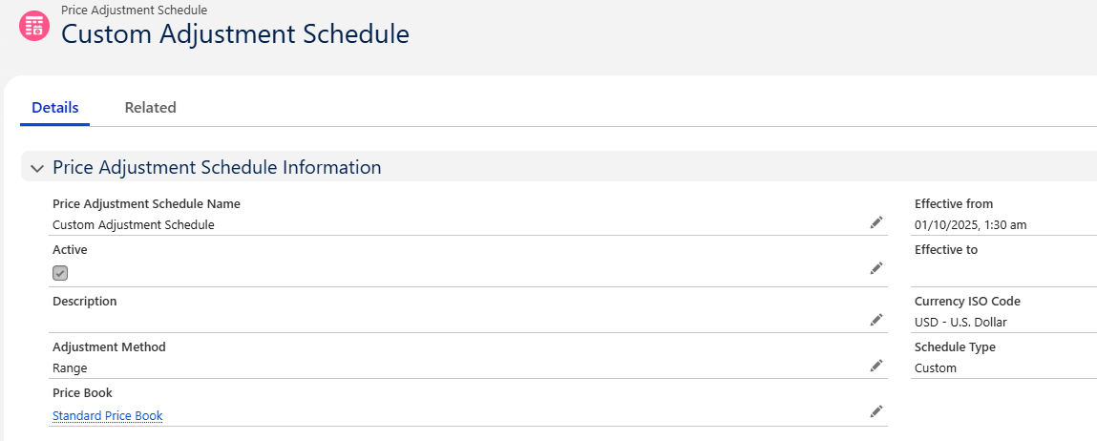
- Created a custom object with the following fields.
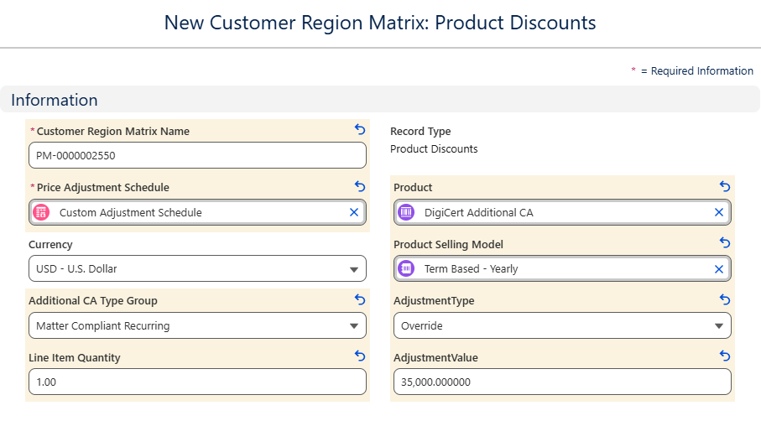
- Create a lookup table and assign the custom object as the source object and map the input and output fields as below:
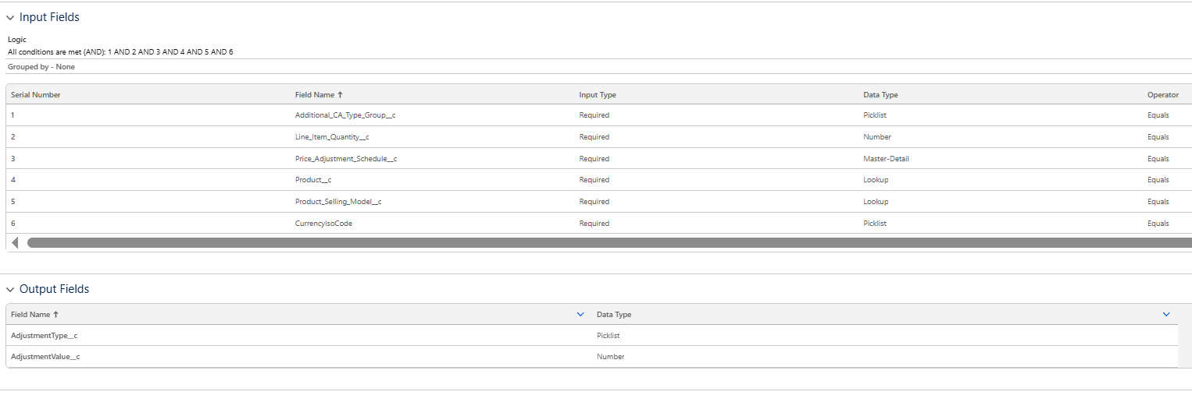
- Add price adjustment matrix element in the pricing procedure and map the parameters
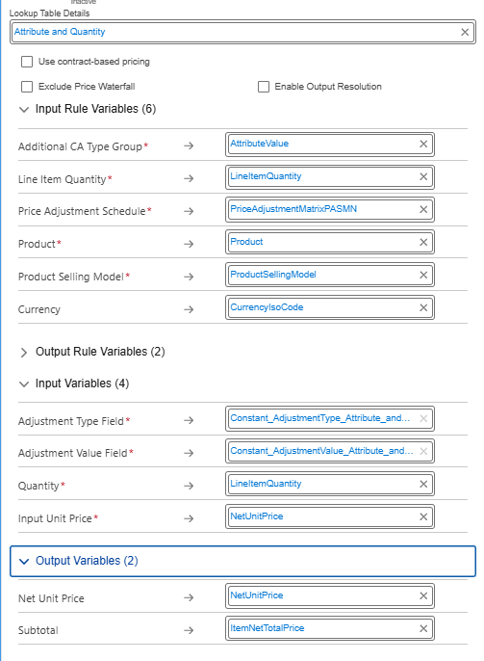
- Verify the results by adding the product to cart by selecting the attribute value of “Additional CA Type” = “Matter Compliant Recurring” and Quantity = 1
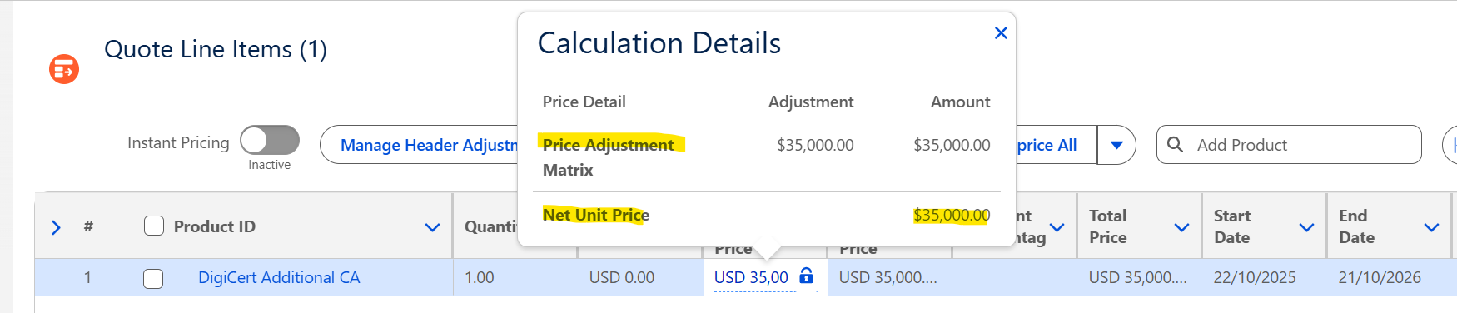

Price Rule Sets:
- Please find the sheet below with the tab “PriceRules with Analysis” which has the RCA approach followed in the to-be system.
PriceRuleSet

Price Matrices and Charge Type Criteria:
- Please find the analysis of price matrices from Digicert existing system in the link below. It has single and multi dimensions.
Price Matrix Analysis-Summarized
- Majority of the price matrices with single dimensions and with attribute specific discounts/overrides are incorporated with attribute based adjustment pricing in the RCA system.
- Any discounts/overrides if based on the quantity will be implemented using volume based adjustment.
- The price matrices from Digicert existing system have majority of 2 dimensions. Here, these 2 dimensions will be incorporated into the volume based adjustment pricing.
- Additionally, the charge type criteria provided in the price list item from Digicert existing system will be considered to include in the attribute based adjustment pricing as the prices of the PLI’s in the existing system are driven based on the attribute selection.
Pricing Callback:

User Story # | User Story Details
RCA-309 | As an RCA Admin, I want to create and manage Price Books and Price Book Entries in RCA so that products are linked with the correct price list, currency, and region for accurate pricing in quotes.
Acceptance Criteria | - As a RCA Admin, I can create, edit, and activate price books for different regions and currencies.  - I can add or update price book entries for products with list price and effective dates.  - I can ensure each product is associated with the correct price book based on region or currency.
Solution Summary | - Salesforce RCA utilizes standard Salesforce objects for maintaining Price Books and Price Book Entries. The pricing data is consumed by the Pricing Procedure through Decision Table.  Here is the step-by-step approach to linking products with the correct price list and currency.  - Enable Multi-Currency: Digicert environment is already enabled for multicurrency.  - Activate all the necessary currencies (USD, EUR, GBP, etc.) that DigiCert has provided.  - Create and Define Price Books: Navigate to the Price Books object and create a Custom Price Book for each distinct price list provided by Digicert. Digicert has provided the 11 pricelists  - APAC - TWD  - UK - GBP  - EMEA - SEK  - APAC - HKD  - NA - USD  - APAC - SGD  - Japan - JPY  - EMEA - EUR  - Australia - AUD  - China - CNY  - EMEA - CHF  - Define Currency: While a Price Book doesn't store a single currency, it acts as a container for entries priced in various currencies.  - Create Price Book Entries: Ensure each product has the Price Book Entries for each currency required within that Price Book. As confirmed by Digicert, each product will be associated with all 11 Price Book and Subsequent Price Book Entries.  - Select the Product Selling Model for each Price Book Entry.  - Make sure the Price Book and Price Book entry are active.  - Initiate the pricing sync from Set up → Feature Settings → Salesfroce Pricing Setup → Sync Pricing Data (click on the sync button). This will create the entries in the Decision Table Price Book Entries v2.  - In the pricing procedure, when provided with the decision table Price Book Entries v2, the system will pick the list price and display it in the quote when a product is added.

Price Book Entries Creation:
Please find our analysis below after reviewing the PriceListItems from the current system(please refer the sheet below).
Digicert Analysis
We have identified the following scenarios based on the different combinations observed:
1. Multiple PLIs with the same charge type, different price type, but the list price will be determined based on the charge type condition.
Example:
PriceListItem ID | Product | Charge Type | Price Type | Frequency
a6k4z000000zlTwAAI | DIGICERT PKI PLATFORM - ADDITIONAL CA | License Fee | One Time | -
a6k4z000001QsI0AAK | DIGICERT PKI PLATFORM - ADDITIONAL CA | License Fee | Recurring | Yearly
Solution Approach: We will create two product selling models, one with One-Time and the other with Term Defined - Yearly. Both selling models will be visible in the catalog, and the product should be added twice as required.

2. Multiple PLIs with different charge types, same price types, and frequency.
Example:
PriceListItem ID | Product | Charge Type | Price Type | Frequency
a6k0z000000aQRKAA2 | DIGICERT PKI PLATFORM - SMART METER CERTIFICATES - 12 MONTHS | Private Root Creation and Maintenance | Recurring | Yearly
a6k0z000000aQpiAAE | DIGICERT PKI PLATFORM - SMART METER CERTIFICATES - 12 MONTHS | Subscription Fee | Recurring | Yearly
- We have two potential approaches for this case.
Solution Approach 1(Accepted by Digicert):
- By default, the Subscription Fee will be displayed in the cart. To support the current functionality, we will create an additional product appended with the charge type name to display the separate pricing. The second product will be added automatically based on charge type criteria and shown as an identifier in the cart.
Solution Approach 2:
- Display both the Subscription Fee and Private Root Creation and Maintenance Fee prices under the same product. This approach will not require additional product creation.
3. Multiple PLIs with the same charge type, same price type
Example:
PriceListItem ID | Product | Charge Type | Price Type | Frequency
a6k0z000000aRXJAA2 | Basic EV FQDN SAN | License Fee | Recurring | Yearly
a6kVu0000007zAIIAY | Basic EV FQDN SAN | License Fee | Recurring | Yearly
Solution Approach: We will create a single product selling model with a Term Defined-Yearly. The charge type criteria from the current system will be used to determine the list price.

User Story # | User Story Details
RCA-294 | Renewal pricing
Acceptance Criteria
Solution Summary

User Story # | User Story Details
RCA-310 | Amendment pricing
Acceptance Criteria | - As a RCA Admin, I shall be able to configure delta price on an amendment, termination and superdede quotes-  - When a user initiates an amendment/termination/supersedes, the system shall automatically reference the active contract and its associated order lines or assets.  - The pricing engine shall calculate amendment prices based on delta logic, ensuring only incremental or decremental value changes are priced. E.g.- When quantities are increased, the system calculates pro-rated charges for the remaining term duration.  - When quantities are decreased or products are removed, the system calculates credits or negative adjustments as per configuration.  - The delta pricing calculated shall be applied back on the amendment, termination & rebook opportunity (supersede), or be issued as a credit note to the customer post order booking.
Solution Summary

User Story # | User Story Details
RCA-214 | Migrating existing PCB custom logic from Apptus to RCA
Acceptance Criteria | - As a RCA Admin, I shall configure the existing PCB logic from Apptus into RCA using price rules, pricing procedures etc.  - All existing Apttus pricing callbacks (Pre-Price, Post-Price, Post-Adjustment, etc.) are identified, catalogued, and mapped to equivalent RLM functionality.  - Each callback’s trigger point, input parameters, and output variables are documented before migration.  - Dependencies on external objects (e.g., Opportunity, Account, custom fields) are reviewed for compatibility in RLM.
Solution Summary

User Story # | User Story Details
RCA-358 | As an RCA Admin, I want to capture and store CPI (Consumer Price Index) adjustment % at the line item level and send it downstream to NetSuite, so that pricing changes align with inflation-based adjustments.
Acceptance Criteria | - As an RCA Admin, I can define and capture CPI adjustment % for each line item in a quote. The system ensures CPI % is passed downstream to NetSuite for accurate billing and reporting.
Solution Summary

User Story # | User Story Details
RCA-311 | Enable historical/original deal pricing for renewal quotes.
Acceptance Criteria | As a Sales Rep, when working on a renewals quote, then  - System shall default the net unit price based on original asset price.  - The list price will be derived based on the current active price list.  - The net price will be calculated based on the net unit price instead of list price for a renewal line on the quote.  - The system shall support uplift percentages at product level on a renewal transaction.  Uplift rules shall be automatically applied during renewal quote generation.
Solution Summary

3.6 Approval Management:

User Story # | User Story Details
RCA-70 | Setup approval rules in RCA based on existing approval criteria in Apttus (Discount, Product, All others) Approval rule matrix: 1. Quote level approvals 2. Line level approvals
RCA-45 | As an Admin, I should enable Approval history on the quote record so that the sales rep can view a complete log of all approval actions related to the quote for better visibility and traceability.
RCA-46 | Enable sequential approval workflow on the quote
Acceptance Criteria | - As a RCA Admin, I want to setup the approval process in RCA based on the existing approval rule matrix from Apttus on the quote object.  - As an RCA Admin, I need to enable a standard approval process, rules, and criteria.  - The approval process is triggered based on predefined criteria (e.g., deal size, discount level).  - As a sales rep, I should be able to submit the quote for approvals-  - if there are any proposal line item approvals : The system should trigger the Approvals if any Line items meet the defined Approval Criteria and change the status as Approval Required.  - If there are any proposal Level Approvals: If any Approval Criteria matches with the Quote configuration, system should change the quote status as Approval Required  - The quote will be locked for editing once it enters the approval process.
Solution Summary | - Approvals in Salesforce Revenue Cloud Advanced are managed primarily through Salesforce Flow and the standard Approval Process framework, offering a streamlined, declarative approach for complex workflows.  - The solution to manage both the approval submissions (the act of sending the record for approval) and the approval work items (the tasks waiting for the approver) relies on configuring specific Flows and leveraging Salesforce features.  - Below are the personas involved in Approvals  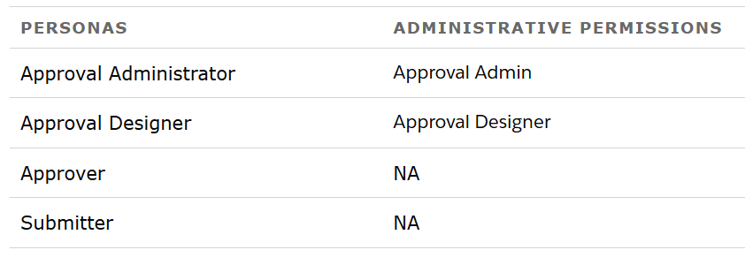  Types of Approval Workflows:  - Advanced Approvals supports different kinds of approval workflows allowing approval designers to create the right approval flow for your business.  - Serial workflows - Simple approval chains that require approvals in a certain order.  - Parallel workflows - Complex approval chains that require approvals from multiple departments.  - Record-triggered workflows - When records are changed, automatically trigger an approval flow.  - Auto-launched workflows - Approvals that your sales reps can launch from their transactions.  Approval Work Items:  - Approval work items an object that contain all the assigned approval work items. The approver can access the record from the approval work items object and pick up the records whose status is Assigned.  - The approval work item can also be accessed from the quote record.  Approval History:  - Approval history will be available on the Quote record to track the status of the approval.  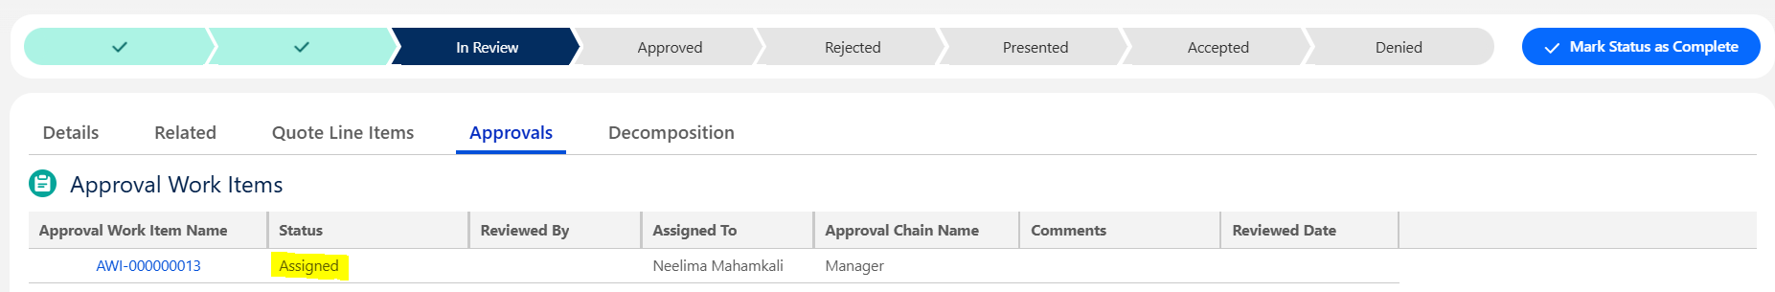

User Story # | User Story Details
RCA-69 | Implement smart approvals in RCA so the system doesn’t require re-approval on all approval criteria even though it was approved before in the quote lifecycle.
RCA-65 | Auto reapprovals for discounts on price changes within a certain threshold
Acceptance Criteria | - As an RCA Admin, I want to configure Smart Approvals so that in case of a rejection scenario, after resubmission, only certain approvals will require reapproval from the corresponding approvers.  - The system will only warrant a reapproval on all discount level approvals even if they were approved prior.  - All other approvals if already approved, will not require reapproval if the underlying fields are not changed.
Solution Summary | - Salesforce RCA smart approvals streamline the approval resubmission process for the users. When smart approvals are enabled on an approval step, Advanced Approvals uses the results of the previous submission to route the resubmission to approvers who need to review it.  - The smart approval process compares the entry conditions during resubmission with the entry conditions of the previous submission. Conditions are stored in the ApprovalWorkItemCondition object, and the logic by which they're evaluated is stored in the ApprovalWorkItemCriteria object.  - If the values fall within the range defined in the ApprovalWorkItemCondition object, the approvers for that step aren’t asked to approve it again during resubmission.  Enable Smart Approval:  - To enable smart approval for an approval step, select the Use Smart Approval checkbox for the record that's being reviewed.  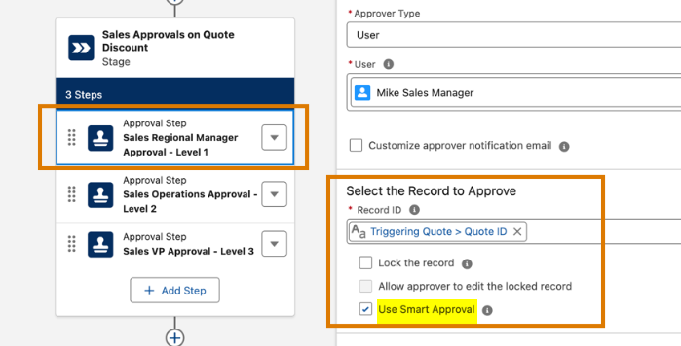

User Story # | User Story Details
RCA-66 | Ability to trigger Approval email notifications to respective users
Acceptance Criteria | - As a sales rep, when I submit the quote for approval, the system should trigger the Email Notifications as follows:  - Approval assignment: Assigned user/queue members  - Approval notification (no action, notify purpose only): As-Is based on the below approval rule entries
Solution Summary | - By default, a flow approval process sends email notifications to assigned approvers, their delegates, and approval submitters. This is configured in the setup → in the quick find search for approval settings.  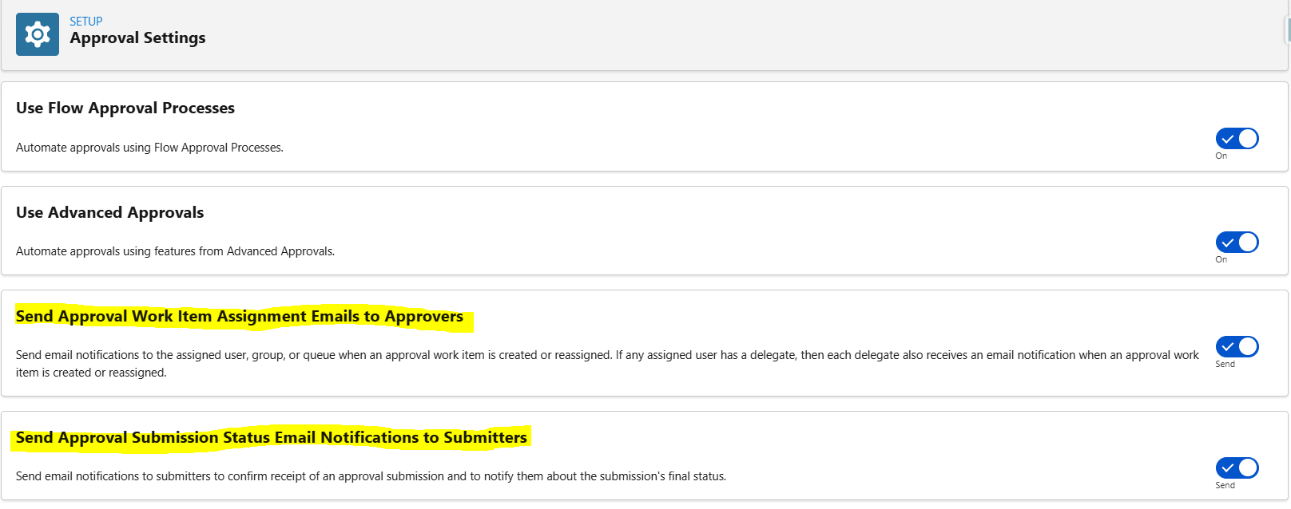  - To change the email notification sent to both approvers and their delegates, customize the associated approval step.  - An email notification can be configured at the step level as shown below. The email notification will be assigned to the approver which can be user/queue.  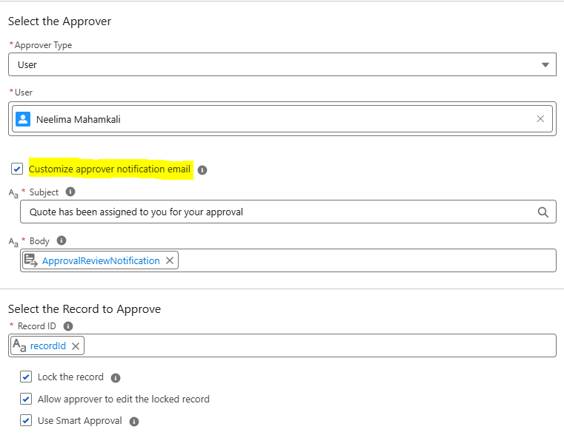

User Story # | User Story Details
RCA-40 | Ability to Auto-approve simple deals that meets criteria:1. Based on product master for discounted products
Acceptance Criteria | - As an RCA Admin, I should have the auto-approval process and rules set up so that certain approval rules can be auto-approved.  - If all the criteria is met, the system auto-approves and updates the quote status to Approved.  - Timestamp and assignee name is stamped in the quote history as part of the auto-approval.
Solution Summary | - An auto approval flow to be set up in the flow orchestration to automatically approve the submissions.  - When an approval submission based on a flow approval process with no approval steps runs, the approval submission is always approved. So, add the conditions in the decision accordingly to auto approve a quote.  - Please find a sample scenario to auto approve a quote. In the below sample approval flow a decision is added to verify if the discount is < 25% then auto approve the quote.  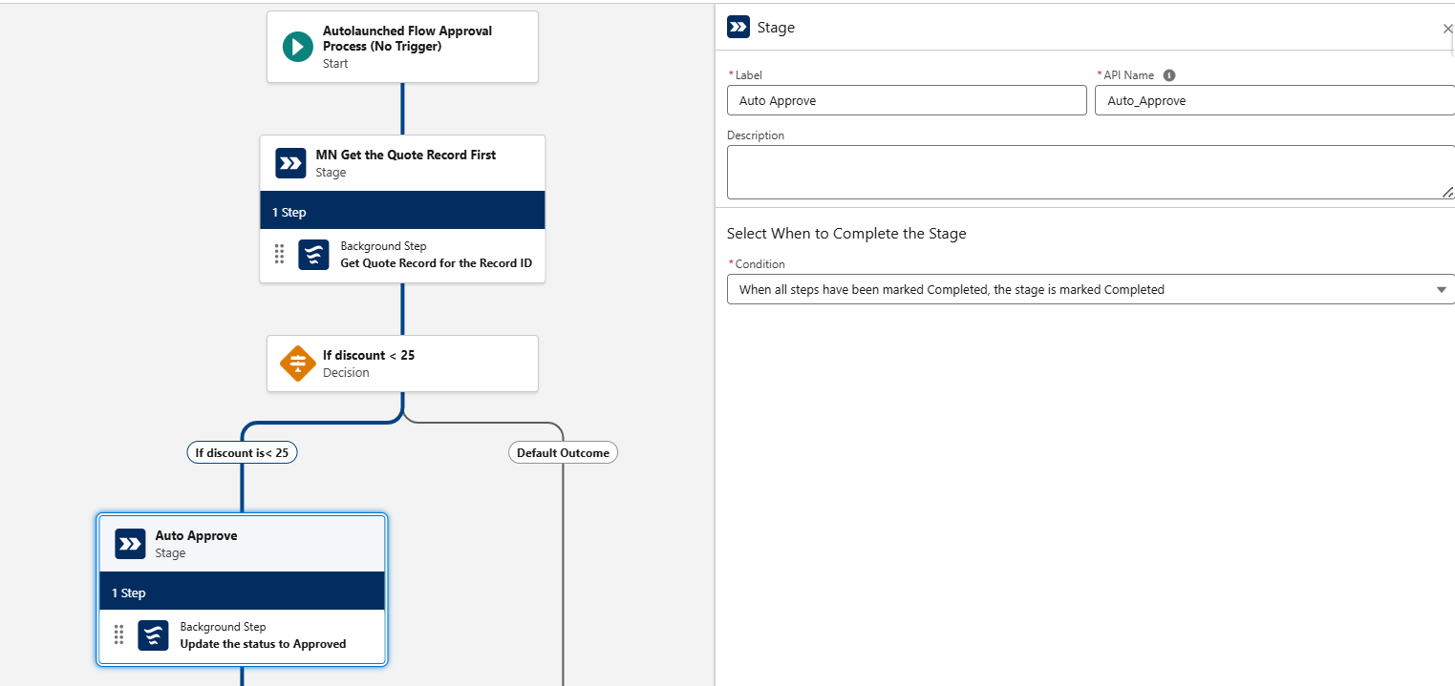  - The above auto approve stage does not have a step defined. Also there is a background flow to update the quote status to approved.  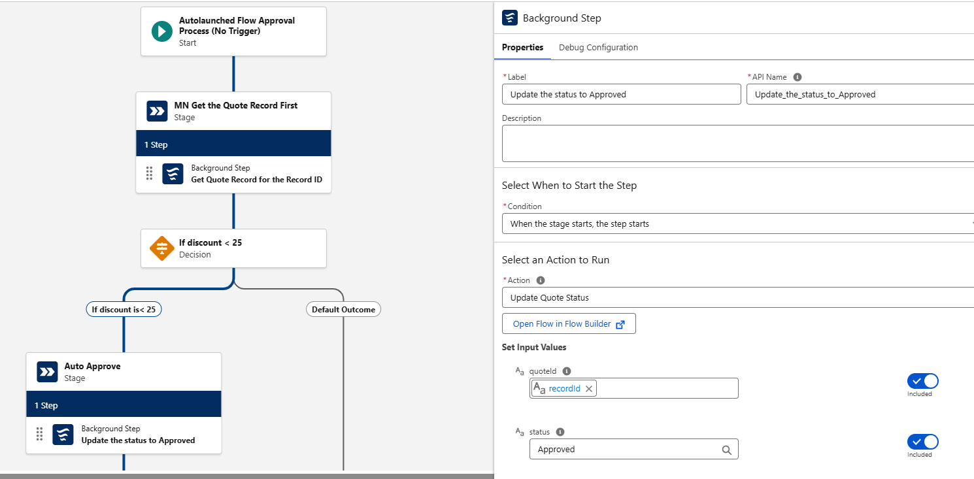  - The approval submission record shows the status as Approved automatically.  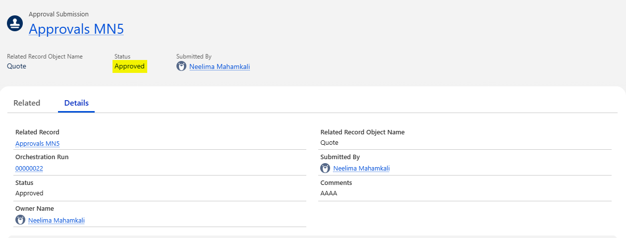

User Story # | User Story Details
RCA-51 | To Enable Delegate Approvlas - Allow approvers to Delegate the pending approvals to the members from the approval queue
Acceptance Criteria | As an RCA Admin, I should be able to configure Salesforce RCA’s standard “Delegate Approver” functionality to allow approvers to delegate their pending approval requests to other eligible members of the same approval queue.  The “Delegate” action or button must be visible on the Approval Request record only when the approval status is “Pending Approval.”  When the Delegate action is initiated, the system should display a lookup field or selection list populated with users assigned to the same approval queue as the original approver.  Upon delegation:  The Approval Request must automatically update to reflect the new delegate approver.  The Approval Request History must record the delegation event, including original approver, delegate approver, timestamp, and comments (if any).  The system must send an automatic email notification to the delegate approver, informing them that a quote approval request has been delegated to them.  The original approver should no longer see the delegated approval request in their Pending Approvals list once delegation is completed.  The delegate approver must have the same level of access and permissions as the original approver to perform the approval action.  Delegation should be permitted only once per approval request, as per RCA standard functionality, to maintain process integrity.
Solution Summary | Delegated approvals in Salesforce Revenue Cloud Advanced (RCA) are managed using the standard Salesforce platform functionality for delegation, as RCA leverages the core platform's Flow and Approval Processes for its workflows.  1. Setting Up Delegation (The Approver's Action)  Delegation is not configured by the RCA Admin but by the Approver themselves, ensuring it respects the individual user's preferences and security permissions.  Access Personal Settings: The primary approver (e.g., the Sales Manager) navigates to their Personal Settings in Salesforce.  Find Delegation Area: They search for and select Delegated Approvers or Advanced User Details.  Specify Delegate: The approver specifies another active user (the delegate) who will receive their approval requests when they are unavailable.  Set Timeframe (Optional): They can set a specific start and end date for the delegation period.  Result: Any Approval Work Item that would normally go to the primary approver will automatically be routed to the delegate during the specified timeframe.  2. RCA Flow and Approval Process Integration  The RCA approval process does not need special configuration to handle delegation; it automatically respects the platform setting.  Submission Remains Unchanged: The RCA Flow that uses the Submit for Approval action continues to target the primary approver (e.g., the User's Manager field).  Platform Routing: The Salesforce platform intercepts the submission and automatically routes the Approval Work Item to the designated delegate, as the delegate now appears in the queue of the primary approver.  Audit Trail: The Approval History related list on the Quote record will show that the primary approver's request was completed by the delegate, maintaining a full audit trail.  Note: The delegated user must have the necessary permissions and visibility (e.g., access to the Quote object and the required page layout) to view and act on the approval request.

User Story # | User Story Details
RCA-53 | Implement Auto-escalations for quote approvals
Acceptance Criteria
Solution Summary | - Salesforce RCA does not provide an option to configure escalations in the approval orchestration process.  - Create a scheduled flow on the approval work time to identify the approval work item pending items with various SLA’s and send an email notification.

User Story # | User Story Details
RCA-44 | As a Sales Rep, I need the ability to recall a quote from the approval process, so that I can make additional changes before it is approved or rejected.
RCA-63 | Ability to approve/reject approvals on the quote in RCA
Acceptance Criteria
Solution Summary | Recall Approvals:  - Use the Approval Submissions list view to recall an approval submission.  - On the navigation bar, click App Launcher icon.  - In the search box, enter approval, and then select Approval Submissions.  - To see pending approval submission, from the dropdown list, select Pending Approval Submissions.  - The submitted approvals can be recalled by selecting the in progress approval submission record and click on “Recall”.  - The system will ask for confirmation, as the recall action cannot be undone.  - Later, the system asks for comments.  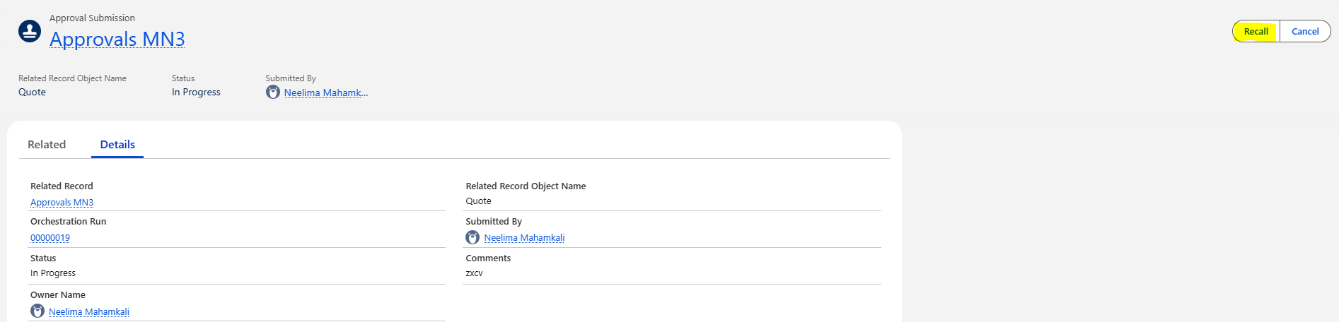  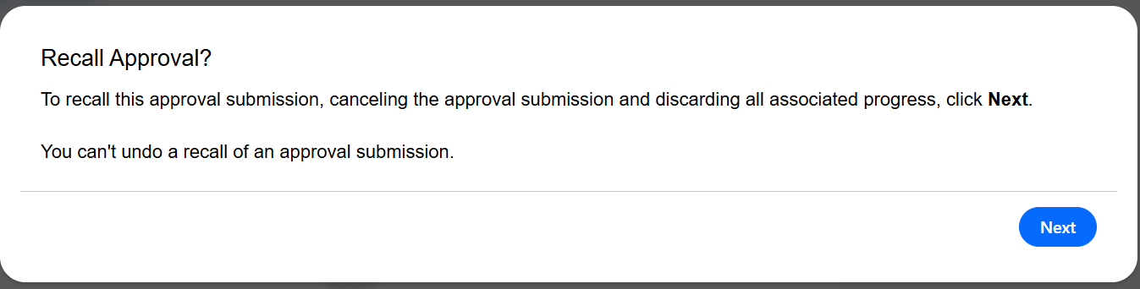  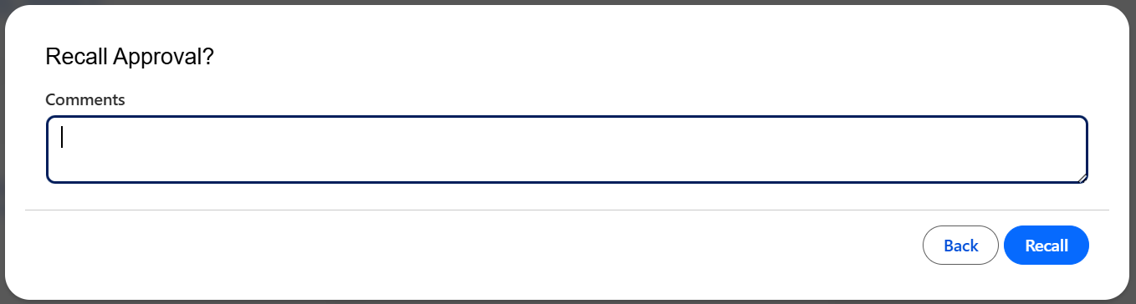  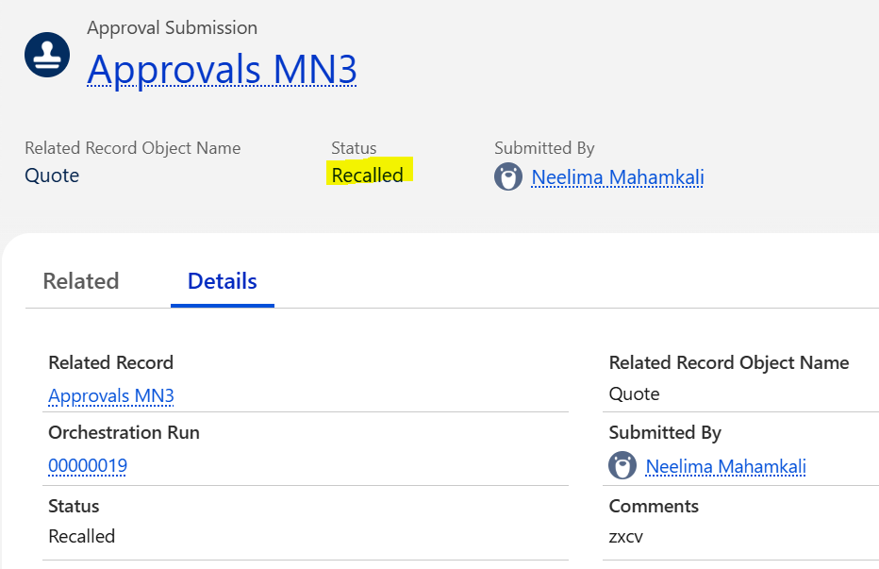  - The corresponding approval work item status will be updated to Recalled.  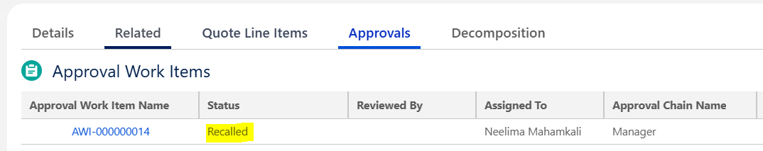  Approve/Reject Approvals:  - The approval work item can be approved/rejected by selecting the “Review” button from the approval work item record.  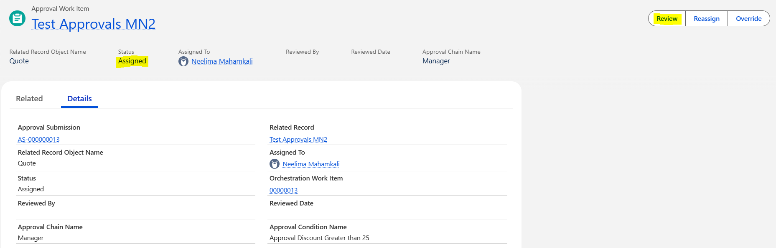  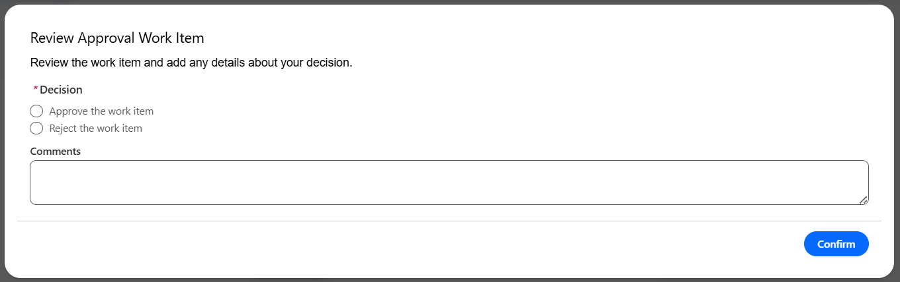

User Story # | User Story Details
RCA-47 | Ability to resubmit a rejected approval on the quote (Sequencial/Parallel approvals)
Acceptance Criteria
Solution Summary | - The system should allow resubmission of the approvals from the quote record.  - The rejected quote should not be allowed to go ahead with the next stages of quote lifecycle.  - Sales user should click on Submit for Approvals button on the quote header to see if the approvals are required on the quote.  - Without completing the approvals, user should not go with the next process on the quote life cycle.  - Set action visibility filters on the Submit for Approval button from the lightning app builder to show the button conditionally.  - Show the Submit for Approval button only when quote status = Draft and Rejected giving the ability to submit the approvals.  - When the quote status is Draft or Rejected, hide the other buttons like generate pdf, send email to customer, send for signatures, ready for review buttons restricting the user from proceeding with the next steps without quote approvals.  - If a quote does not fall under the approval criteria, update the quote status to approved automatically. This is achieved in the approval flow orchestrator by adding a background step and referring to a flow to update the quote status as shown below  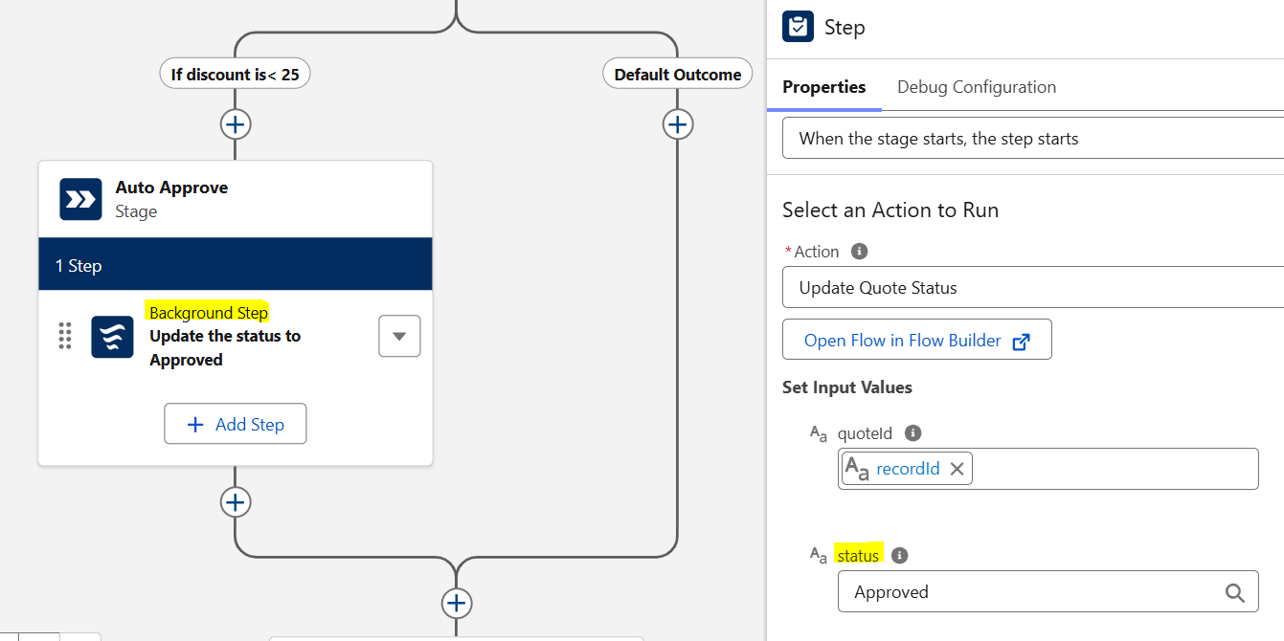

User Story # | User Story Details
RCA-57 | Enable email based approvals in Salesforce RCA
Acceptance Criteria
Solution Summary | - Approvals can be automatically approved via email without even logging into the system.  - The email response from setup → process automation settings → Enable email approval response should be enabled.  - Additionally, an org-wide email address should be configured and should be provided in the Automated Process User Email Address.  After completion of the the steps mentioned above, the automated email response will include the steps to approve via email show below:  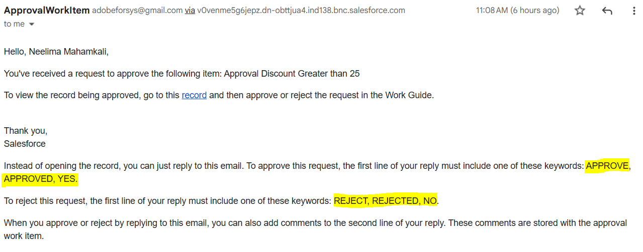  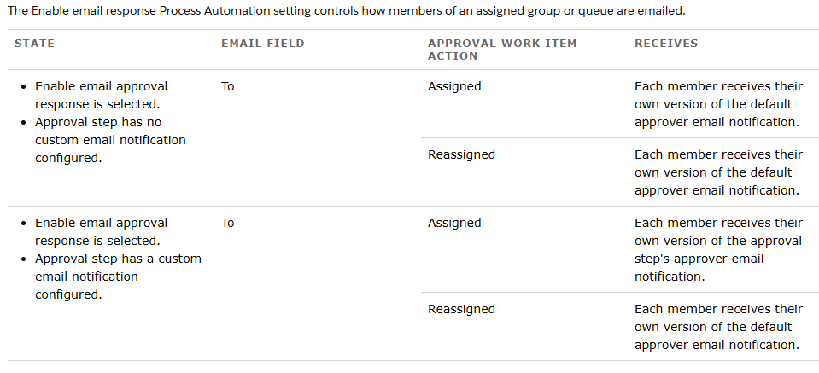

User Story # | User Story Details
RCA-61 | As a RCA Admin, I need to set up user/queues/Custom users for approval assignment.
Acceptance Criteria
Solution Summary | - The approval orchestration provides the following approver types from the system and the ownership of the approval work item will be with the respective user.  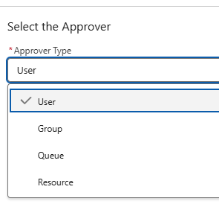  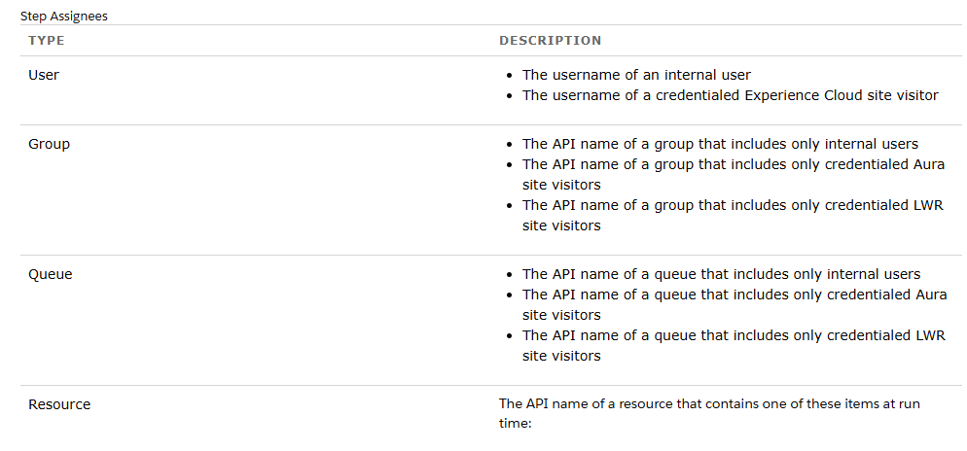

User Story # | User Story Details
RCA-60 | As a RCA Admin, I need to configure custom actions within approval notifications.
Acceptance Criteria
Solution Summary | - In the custom VF email template, the approval actions should be included so that the user can approve it via email.  - Approve, Reject buttons should be available in the email notification.

User Story # | User Story Details
RCA-59 | As a RCA Admin, I need to set up a backup admin for the approval process.
Acceptance Criteria
Solution Summary

User Story # | User Story Details
RCA-67 | As a Business Desk representative, I need the ability to reassign a pending quote approval to a different user or approval queue, so that I can quickly move the deal forward if the originally assigned approver is unavailable or delayed.
Acceptance Criteria
Solution Summary | - On the approval work item to reassign a pending quote approval to a different user, an out-of-the-box button “Reassign” is provided on the layout.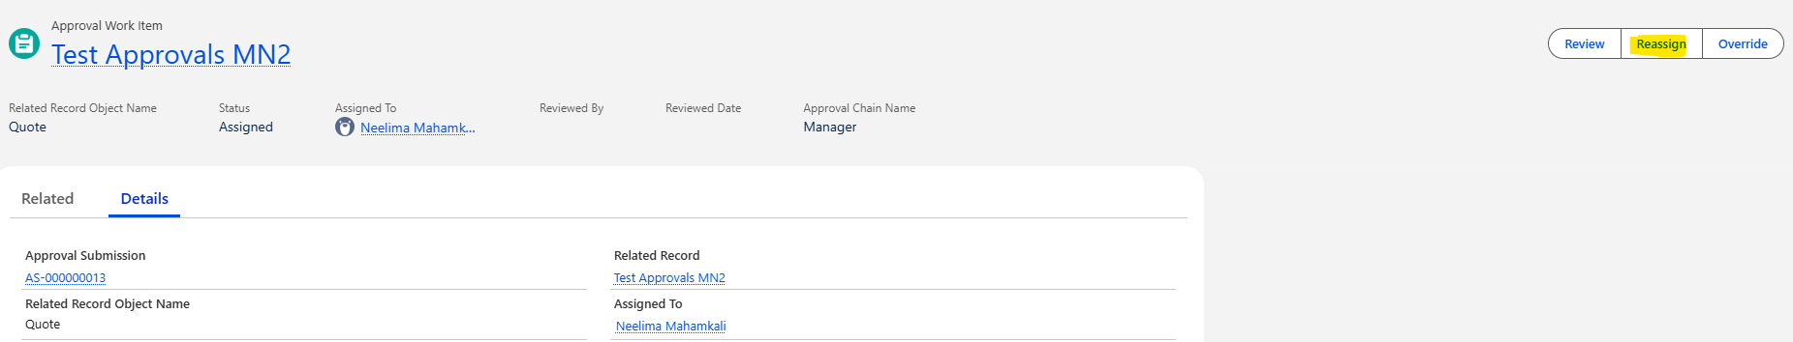  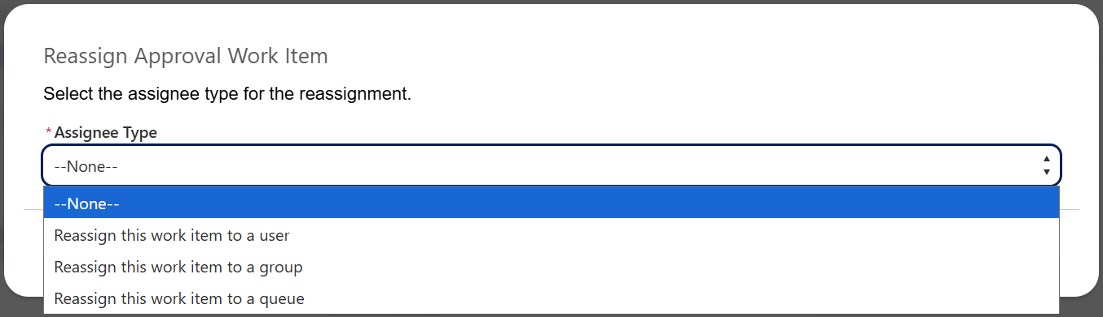

Quote Management:

User Story # | User Story Details
RCA-107 | Reps should be able to select all the products in the catalogue by navigating through catalogue hierarchy
Acceptance Criteria | - As a Sales Rep, I should be able to view the respective catalog and category of products to select from-  - Each category should show the corresponding products for the users to select from.  - There should be an 'All products' category which should show all products within that catalog (within the contract type selected on the quote).  - There should be an ‘All Products’ catalog that includes all products (within the contract type selected on the quote).
Solution Summary | - Catalog and Category capabilities in Salesforce Revenue Cloud Advanced are fundamental features of the Product Catalog Management, providing a hierarchical and flexible structure far beyond the simple "Product Family" picklist used in standard Salesforce.  - These capabilities are designed to manage product visibility, improve sales rep browsing efficiency, and support multi-channel sales.  - Products are explicitly assigned to one or more Categories. The category then links to the Catalog.

User Story # | User Story Details
RCA-114 | As an RCA Admin, I should be able to enable the contract type picklist field on quotation object validation to restrict users from changing the contract type if any proposal line item exists
RCA-86 | The Contract type and the opportunity type should be defaulted from Opportunity to Quote
RCA-129 | As a Sales Rep, I want to view and navigate the product catalog based on the selected Contract Type, so that I only see the relevant products applicable to that specific contract
RCA-125 | Reps should be allowed to create opportuities for partner contract types and should follow the current processPartner contract types:Per Cert Ongoing - Zero dollar contracts, monthly invoicing based on usagePer Cert PayGo - Zero dollar contracts, credit card payment per transactionBulk Dollar - Upfront payment deposited, decremented with usage
Acceptance Criteria | - As a RCA Admin, I should enable contract type pick list on the quote object.  I should able to view the below picklist values on this field -  - Direct Subscription (Standard)  - Partner Bulk Dollar (Standard)  - Partner Per Cert: PayGo  - Partner Per Cert: Ongoing  - Partner Per Cert: Voucher (Special Discount)  - Direct Custom Contract  - Direct Flat Fee  - Direct Bulk Units (Standard)  - Direct ELA  - As a sales rep, I shall not be able to change the contract type on a quote if there are any proposal line items are already created on the quote.  - A validation message shall be triggered if user tries to change the contract type 'Contract type cannot be changed if proposal line items already exist on the quote.'  - As a sales rep, when I create a quote from an opportunity then system should pull all the relevant infromation from opportunity to quote  - As a Sales Rep, When I open any product catalog from a quote, the system should filter products based on the associated Contract Type (e.g., Subscription, Bulk-$, Bulk-Units, PerCert) , I should only view products valid for the selected Contract Type are displayed.  - I should not be able to view the products that are not aligned with the quote’s Contract Type.  - I should be able to view and see all the various catalogs / categories with valid SKUS for that contract type.
Solution Summary | - Contract Type is a custom picklist field selected on the quotation. Browse Catalog button will be hidden until the contract type and deal type on the quote is selected.  - Contract Type field selection will happen on the Quotation. Once the quote is synced, the contract type selected on the quote should sync back to opportunity.  - Based on the Contract Type value selection, the catalog and product visibility should be restricted.  - The visibility of the product can be handled by configuring qualification rules.  - If the sales rep tries to modify the contract type on the quote after creating the quote line item, system should throw a validation message restricting the user. Either all the quote lines should be deleted or should create a new quote.

User Story # | User Story Details
RCA-111 | As a Sales Rep, I should only access installed products during Amendment or Expansion, terminations, and supersede quotes
Acceptance Criteria | As a sales rep, I should be able to view and select installed products only for Amendments, Expansions, terminations, and supersede. quotes.  I shouldn't be able to view the installed products on other quotes line - " New logo"
Solution Summary | - The Add Assets feature in Salesforce Revenue Cloud Advanced (RCA) is part of its Asset-Based Ordering (ABO) capability. It allows a sales rep to select a customer's existing purchased products (Assets or Subscriptions) to be added to a new quote for modification (Amend), renewal, or cancellation.  - To show the “Add Assets” button conditionally, in the lightning builder app two TLE components should be added one TLE with Add Assets and one without Add Assets button and add condition to the component to hide the visibility. The visibility of a component will be driven by the Quote Type field on the Quote header.

User Story # | User Story Details
RCA-113 | Ability to auto-generate price ramps incase of multi-year deals.Define Quantity, price and the discounts for Segments per year or custom periods
Acceptance Criteria | As a sales rep, I should be able to auto-generate price ramps for multi-year deals  A custom field (proposal) or a custom action on the cart shall be created for the user to select if multi-year ramps need to be created for all proposal line items automatically.  Based on the selection, system should create ramps for all products on the cart with default price per year (based on the line net price and duration)  This option should only be available for 'New Logo' quotes.
Solution Summary | - The process of creating ramps and the capability of RCA configuration allowing to create ramps in the transaction line editor is already covered as part of product catalog management.

User Story # | User Story Details
RCA-112 | Ability to bulk update Quote lines in the cart like Start and end date, Terms, Discounts
Acceptance Criteria | As a sales rep, I shall be able to perform mass update on below fields on the RCA cart-  - Billing rule : Picklist value - Bill in Advance, Bill in Arrears  - Billing frequency : Monthly, Quarterly, Half Yearly, One-Time, Yearly  - Quantity  - Adjustment Type :  - % Discount: Applied on the Net Unit Price  - Discount amount (bundle only): Applied on the Net Unit Price  - Price Override: Applied on the Net Unit Price  - % Markup: Applied on the Net Unit Price  - Markup Amount (bundle only): Applied on the Net Unit Price  - As a sales rep, I shall also be able to update the below fields at a line level-  - Start Date  - End Date  - % Discount: Applied on the Net Unit Price  - Price Override: Applied on the Net Unit Price  - % Markup: Applied on the Net Unit Price
Solution Summary | - The ability to bulk update Quote lines in Salesforce Revenue Cloud Advanced is achieved declaratively through the Transaction Line Editor (TLE).  - The TLE supports inline editing across multiple records, allowing sales reps to update key fields efficiently.  - Editability: Ensure the target fields—such as Start Date, End Date, Subscription Term, and Discount %—are set as editable for the relevant user profiles.  - Action: The sales rep can select multiple line items and use the standard inline edit feature (often by double-clicking a cell) to update the field for all selected lines simultaneously.  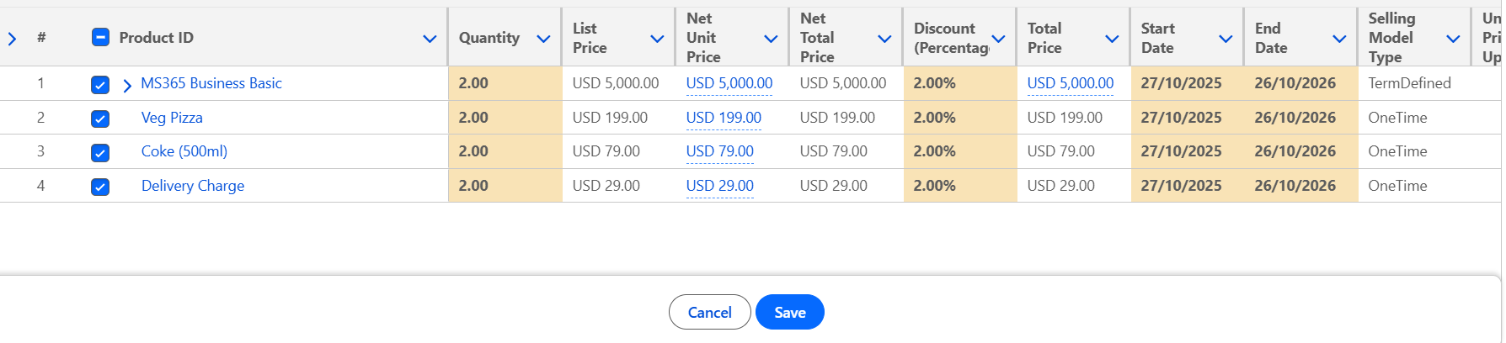  - To delete all the quote lines, “Bulk Delete” button is provided on the TLE.  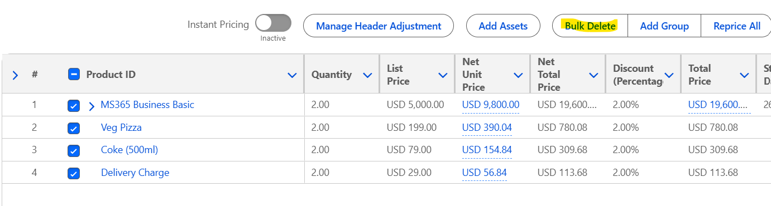

User Story # | User Story Details
RCA-117 | Ability to consolidate Quote templates based on Terms and Conditions
Acceptance Criteria | As a RCA admin, I should be able to consolidate the quotes terms and conditions for the reps to manage the quote templates
Solution Summary

User Story # | User Story Details
RCA-121 | Ability to capture Quote template document information on the quote details
Acceptance Criteria | As a sales rep, I should see system automatically capture all the quote template document information on to the quote details
Solution Summary

User Story # | User Story Details
RCA-124 | Ability to capture provisioning details from the order forms onto the quote
Acceptance Criteria | As a sales rep, I should be able to provising details automatically captured from the order forms onto the quote details
Solution Summary

User Story # | User Story Details
RCA-118 | Opportunity and Quote types should have the same type values
Acceptance Criteria | When a sales rep creates a quote from an opportunity then the quote type should be defaulted from the opportunity type
Solution Summary | - “Quote Type” is a custom picklist field created on the quote object to capture the opportunity types.  - For example, if the opportunity type is new logo, the quote type should be new logo.  - Below are the set of Quote Types that will be part of to-be system  - New Logo  - Amendment  - Renewal  - Early Renewal  - Termination  - Termination and Re-Book

User Story # | User Story Details
RCA-79 | System should support different start and end dates for individual lines with in a single quote
Acceptance Criteria | As a sales rep, I should be to create a quote and add products with different start and end dates with in a single quotes
Solution Summary | - This is an out of the box functionality and sales rep can provide different start and end dates per quote line item.

User Story # | User Story Details
RCA-87 | Quote dates should match with acutal contract dates
Acceptance Criteria | As a sales rep, system should ensure the quote start and end dates match with contract start and end date
Solution Summary

User Story # | User Story Details
RCA-89 | Required field validations on the quote object
RCA-127 | Quote validations in RCA - Implement existing validation rules on salesforce RCA quote object
Acceptance Criteria | - As a sales rep, system should enfore the validations on the required fields on the quote details page  - As an Admin, I should be able to configure and activate validation rules on the Quote object. I should ensure all existing business validation rules are implemented in RCA.
Solution Summary | - All the validation rules in the existing system should lift and shift to the to-be system.  - Without the mandatory fields on the quote record, user should not be able to “Browse Catalog”.  - Browse Catalog button should be hidden if the contract type, deal type, quote type…etc fields are blank. This can be achieved by placing a rule component visibility on the lightning app builder of quote record page.

User Story # | User Story Details
RCA-83 | Ability to Configure product option should be locked during approval process
Acceptance Criteria | As a sales rep, when I submit the quote for approval then I shouldn't be able to configure the products on the quotes.
Solution Summary | - This is an out of the box functionality if the lock the record option is selected in the step in the flow orchestration. All the quote header and quote line item fields will be locked and system does not allow to configure the products.

User Story # | User Story Details
RCA-82 | Any changes in the quote after approvals should set the quote status back to draft
Acceptance Criteria | As a sales rep, when I make any change on the quote after the quote is approved then system should set the quote status back to Draft
Solution Summary | - Any changes performed on the approved quote either at header and line item level should always reset the status to Draft and Submit for Approval button should be enabled.  - Sales Rep should submit the quote for approval and if the changes on the quote does not need any approval then the system will auto approve the quote.

User Story # | User Story Details
RCA-90 | Auto populate Quote name, Start Date and Expiration Date
Acceptance Criteria | As a sales rep, when I create a quote then system should auto populate the quote name with opportunity name, Start date as today's date and Expiration date as 30 days from today's date
Solution Summary | - Following the as-is system, the quote name, start date and expiration date should be populated automatically.  - Create a Record-Triggered Flow on the Quote object (when created) and update the set of fields.

User Story # | User Story Details
RCA-78 | Quote should be locked during approval, and post order submit
Acceptance Criteria | - As a sales rep, I should not be able to perform any action on the Quote if it is pending approval  - When a Quote is in Approval Required or In Review status, all configuration actions should be disabled.  - Once a Quote is approved or accepted, the quote should be locked for editing.  - After Order Submission, the quote remains in a locked state.  - Locking should prevent product, pricing, or field-level changes.
Solution Summary | - Quote will be locked during approvals if Lock record option is selected on the step in the advanced approvals flow orchestration. System will prevent the user from making any changes.  - Once the order is created, the quote record type should be assigned to read only with a read only layout restricting user from making any changes to the quote and quote line items.

User Story # | User Story Details
RCA-109 | Ability to see the prices of the product in the catalogue page
Acceptance Criteria | As a sales rep I should be able to see the list price of the products in the catalog page.
Solution Summary | - This is an out of the box feature which shows the list price for each product in the catalog.

User Story # | User Story Details
RCA-73 | Quote Layout - Configure unified Quote Layout
Acceptance Criteria | As a Admin, i should be able to coinfigure single quote layout for the quoteobject for all the transaction type (e.g., New Business, Amendment, Supersede, Early Renewal) is required at the Quote LevelAs a Admin,  -Field visibility for different user personas (Sales Rep, Sales Ops, Business Desk, etc.) should be controlled using Field-Level Security (FLS), or Conditional Visibility Rules.  -The fields and columns in the cart view (Quote Line Items) will remain largely consistent with the current state.
Solution Summary | - Following the as-is system, the quote layout should be configured in Salesforce RCA quote object.  - The visibility of a field can be configured either by controlling the field level security or by hiding the field from the lightning app builder page layout based on the profile.  - The column fields of the cart from the as-is system should be recreated in the Transaction line editor.

User Story # | User Story Details
RCA-74 | Quote Record Type - configure quote transaction record type in quotation object
Acceptance Criteria | AS a Admin, i should define quote's transaction record type at the Quote Level -  New Business  Amendment  Supersede  Early Renewal  This field selection to be made mandatory as it not just derived from the Opportunity.
Solution Summary | - The quote object will have a single unified layout but the type of quote will be captured in a picklist field “Quote Type”.  - Below are the set of Quote Types that will be part of to-be system  - New Logo  - Amendment  - Renewal  - Early Renewal  - Termination  - Termination and Re-Book  - The Quote Type should be selected by the sales rep manually on the quote.

User Story # | User Story Details
RCA-75 | Quote Status: Define status and execution status fields on the quote object
RCA-126 | Quote Acceptance
RCA-1221 | Need 'Request BD/Legal Help' action on the quote to capture Additional T&C requested by customer
Acceptance Criteria | As an RCA Admin, I should be able to configure the required Quote Status and Execution Status picklist values on the Quote.  As an RCA Admin,  I shall be able to configure the required Quote Status and Execution Status picklist values on the Quote.  Quote Status:  Draft [Default Value]  In Review  Rejected  Approved  Execution Status:  Pending Executable Document [Default Value]  Ready for Execution  Ready for Acceptance  Accepted  As a Sales Rep,  I shall be able to see the default Quote Status as ‘Draft' and Execution status as 'Pending Executable Document’ on quote creation.
Solution Summary | - The OOTB Status field to be leveraged to show Quote Status.  - The Execution Status is a custom picklist field to be created on the Quote object.  - Both the fields Quote Status and Execution Status fields to be marked as read only fields not allowing users to change the value manually.  - The Execution Status field to be added via compact layout  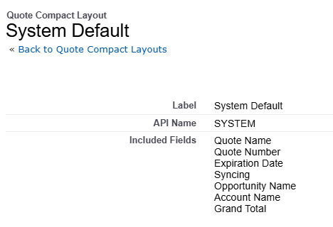  Happy Path:  - On quote creation, Quote Status will be defaulted to Draft as per the OOTB functionality and Execution Status should be set to “Pending Executable Document”.  - After the products are added to the cart, sales rep will click on “Submit for Approval” button to see the approvals are triggered.  - If the configuration does not need any approvals, system should update the status to Approved(This can be achieved via approval orchestration).  - If the quote is eligible for approvals, the quote status will be “In Review”(This can be achieved via approval orchestration). The quote record will be locked during approval which is configured in the approval flow orchestration.  - If the approval is approved, then the Execution Status should be “Ready for Execution”. Hide the Submit for Approval button using the lightning record page.  - If the approval is rejected, the quote status will be “Rejected”. At that time, the Submit for Approval button should not be hidden allowing the user to re-submit. The Execution Status will still be “Pending Executable Document”.  - The sales rep will click on Email Quote to send the generated pdf document to customer.  - Upon approval from customer, sales rep will initiate docusign signatures from send for signatures button.  - Once fully signed, sales rep will click on the action ready for acceptance, which should initiate the screen flow asking for the below information  - Primary Order Form (Upload attachment)  - Order Form Not Required (Checkbox)  - Primary Purchase Order (Upload attachment)  - Purchase Order Not Required (Checkbox)  - If any of the below scenarios is true, the Execution status should be Accepted and order should be created automatically.  - Primary Order Form Has Attachment AND Primary Purchase Order Has Attachment  - Primary Order Form Has Attachment AND Purchase Order Not Required = TRUE  - Order Form Not Required = TRUE AND Primary Purchase Order Has Attachment AND Account ‘Can Order via quote/PO’ = TRUE AND Account ‘Limitations on quote/PO ordering’ = FALSE  - The quotation which does not come under above 3 scenarios, the quote execution status should be ready for acceptance. Additionally, the ownership of the quote should be assigned to Legal queue.  - Legal team will verify the quote and create the order manually, then the execution status will be updated to Accepted.  - Once the quote status is Accepted, the Contract record with the record type = Create Order form should be created automatically by the system. The status of the contract record will be draft.  - The fields from quote should be cascaded to the contract record. The ownership of contract record will be with Biz Desk Queue.  - The contract activation happens from the Order record by order management team along with order activation.  Order Form update (No redlining/ no contract):  - The process flow is same till Step 7 from Happy path. If sales rep receives a feedback from customer to incorporate additional language, then sales rep will click on Request BD or Legal Help button. On the click of the buton, on the screen flow there should be a field to capture the Sales Notes. After submission, Sales Notes field on the quote should be updated.  - This action should create a record in the Request object. Additionally, system creates a Contract record automatically with draft status. (Ownership of the Contract record needs to be decided)  - Request object is an existing custom object managed by Digicert for case management.  - Create a relationship between RCA Quote and Request object where Quote is parent and Request is child.  - The Request record ownership will be based on the field Owner Region on the quote record.  - Create a field on the Quote object following the existing field on the quote/proposal as below:  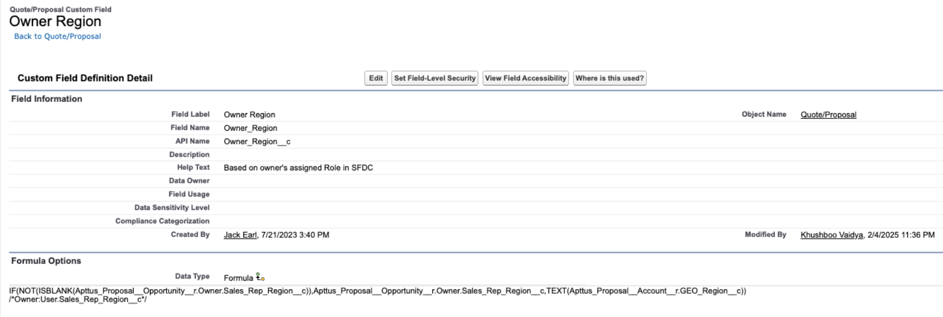  - Based on the region on the field Owner Region, the request record ownership should be assigned to either of the below queues:  - Business Desk - AMS  - Business Desk - EMEA  - Business Desk - APJ  - The Request record owner should receive the email notification upon record creation.  - The case management via Request object will be taken care by DigiCert following their existing process.  - Once the Biz desk updates the Sales Notes with the appropriate language on the quote, closes the case(Request record) and sales rep will receive the notification.  - Now, sales rep will re-generate the quote to incorporate the text from Sales Notes field and submit to customer.  - For the entire process the quote status and execution status will be Approved and Ready for Execution respectively.  - Upon approval from customer, sales rep will initiate docusign signatures from send for signatures button. From here onwards for the next steps please follow Happy path steps 9 to 12.  - The contract activation happens from the Order record by order management team along with order activation.  Order Form update (Contract creation):  - Implementation wise there isn’t anything extra that needs to be incorporated in this scenario. Process wise if biz desk decides to do redlning, he will leverage on the contract record that system has created automatically with the record type = create order form will be used for the redlining with customer.

User Story # | User Story Details
RCA-76 | Quote Fields - Defaulted from opportunity, account, and manual input fields
Acceptance Criteria | As a Sales Rep, When I create a quote from an Opportunity, key fields should auto-fill.  I should see Account-related details automatically populated on the Quote.  I should be able to manually fill in additional fields that are not auto-populated.
Solution Summary | - Following the as-is system, all the mandatory fields from opportunity and account should be cascaded to the quote record.  - After creation of quote from opportunity, system should show a banner message to select the mandatory fields inorder to show browse catalog button  - The remaining fields on the quote should be manually entered by the sales rep.

User Story # | User Story Details
RCA-77 | Quote Actions - Catalog, clone, sync, Submit for approval, generate, send for e-signature, accept, submit order
Acceptance Criteria | As a Sales Rep, I can view all standard action buttons on the Quote page:  I can open the catalog and add or modify products in my quote.  I can clone an existing quote with all details copied.  I can manually sync the quote to have the latest data to the related Opportunity.  I can submit the quote for internal approval whenever it is required.  I can generate a “Draft” watermarked quote document using the configured template.  I can recall a submitted quote from approval  I can send the non-watermarked generated quote to the customer for signature through integrated e-sign.  I can mark the quote as accepted once signed by the customer.( TBC)  I can create/submit the order  I can create contracts  I can delete the quote
Solution Summary | - The ability to manage a quote through its entire lifecycle in Salesforce Revenue Cloud Advanced is defined by a set of key Quote Actions. These actions are typically configured as custom buttons, Flow actions, or integrated functionalities available on the Quote record page or within the Transaction Line Editor (TLE).  - Below are the set of actions that are available on the quote.  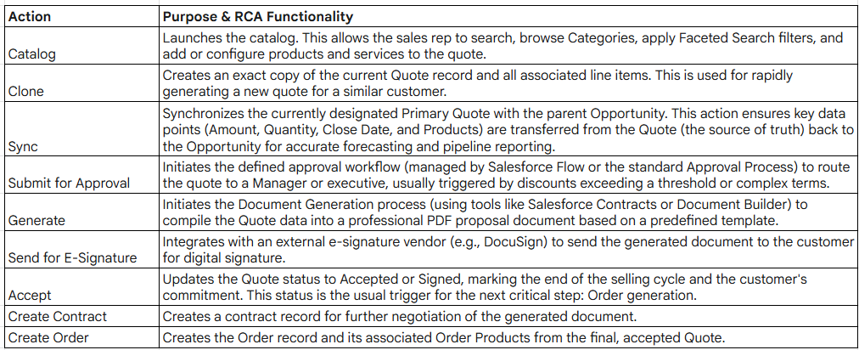

User Story # | User Story Details
RCA-79 | System should support different start and end dates for individual lines with in a single quote
Acceptance Criteria | As a sales rep,  I shall be able to view the start Date and End Date fields at the Quote Line Item level.  The start date for all quote lines shall be defaulted to quote start date.  The end date shall be based on the term selected/defaulted based on the product configuration.  Based on the product configuration rules, user shall update the duration/end date accordingly.  I shall be able to edit start and end dates only for standard and bundle products one line at a time. The dates shall not be editable for any option product.  Quote header updates should not override quote line level dates.
Solution Summary

User Story # | User Story Details
RCA-128 | Ability to search the Product based on the attribute
Acceptance Criteria
Solution Summary | - The ability to search for products based on their Attributes is a standard, declarative capability in Salesforce Revenue Cloud Advanced (RCA), achieved through the Product Discovery component and the underlying Product Catalog Index.  - The system needs to know which characteristics define the product and should be searchable.  - The search engine uses a cached index for speed, so the attributes must be explicitly included.  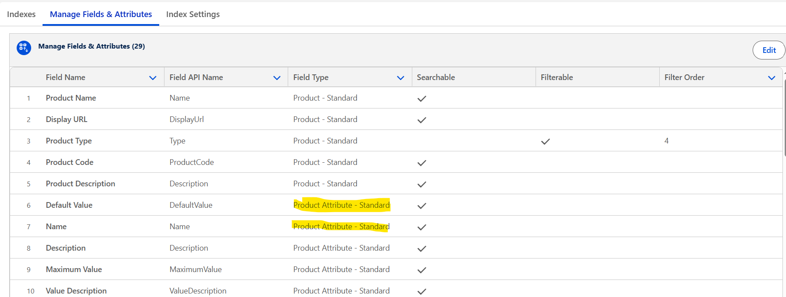

User Story # | User Story Details
RCA-379 | As an RCA Admin, I should be able to configure and create new custom fields as per the requirement on the RCA Quote Line Item object
Acceptance Criteria | - As an RCA Admin, I should be able to create new custom fields on the Quote Line Item object as required.  - All required As-Is custom fields must be recreated in RCA with the correct field type, length, and picklist values.  - As an RCA Admin, I should be able to configure the Quote line item layout according to business requirements.  - As an RCA Admin, I should be able to set field-level security so fields are visible/editable based on user profiles and roles.
Solution Summary

Renewals/ABO:

User Story # | User Story Details
RCA-481 | Amendment: Start/End date on assets
Acceptance Criteria | As a Sales Rep,  I shall be able to view the Start Date and End Date fields on the quote lines-  When a Quote is created, the system shall automatically populate:  Start Date = Quote creation Date  End Date = Existing end date on the asset/contract  For Co-Term scenarios, the end date will be based on co-term date derived from the user selected asset/contract (for amendment with co-term option)
Solution Summary | - When an amendment is initiated from Managed Asset Viewer from Account record, system prompts to enter the Amendment start date.  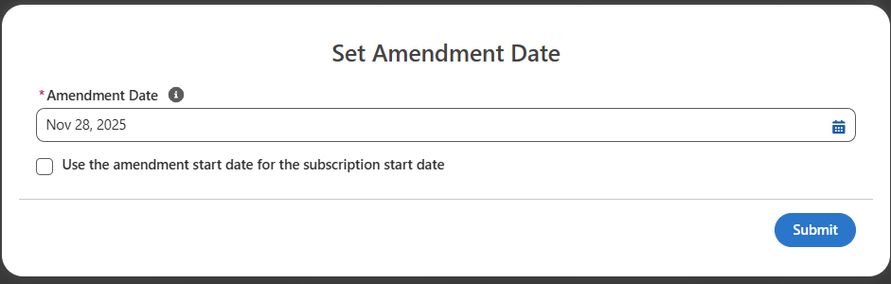  - Once the amendment quote is created, the start date and end date will be populated by the system.  - Here the end date will be by default the end date of the asset lifecycle end date.

User Story # | User Story Details
RCA-451 | Default asset start and end date on the renewals cart
Acceptance Criteria | As a Sales Rep, when working on a renewals quote,  I shall see the default start and end date populated on all quote lines (created for existing assets pulled from the installed products).  The start date shall be defaulted based on previous asset end date + 1.  The end date shall be defaulted based on a default duration added to the start date.  Eg- If the original asset coverage dates were 1/1/2025 - 12/31/2025.  The renewal start date will become 1/1/2026. If there is a renewal term defined for respective product(s), it can be applied to calculate the renewal duration on the quote. Else a default blanket renewal duration can be applied for all renewal transactions - 12 months, 24 months etc.
Solution Summary | - When a renewal is initiated from Managed Asset Viewer from Account record, system prompts to set the renewal term.  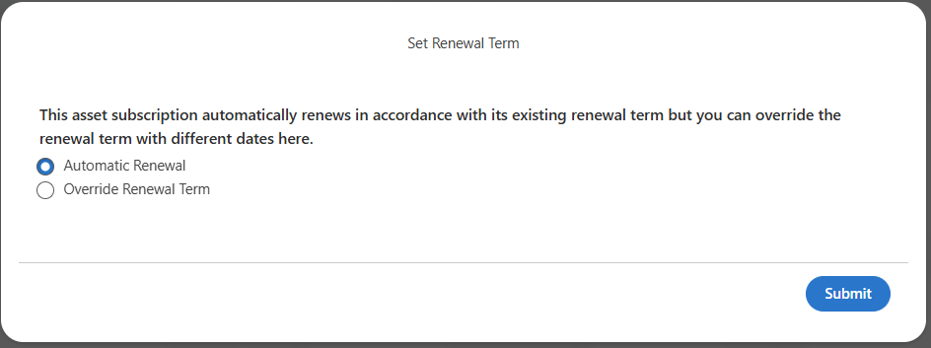  - If Automatic Renewal is selected, system will create a renewal quote and the start date of renewal quote will be previous asset end date+1 and the end date will be the renewal term on the previous asset.  - If Override Renewal Term is selected by sales rep, Renewal start date and end date to be selected manually which will cascade on to the renewal quote.  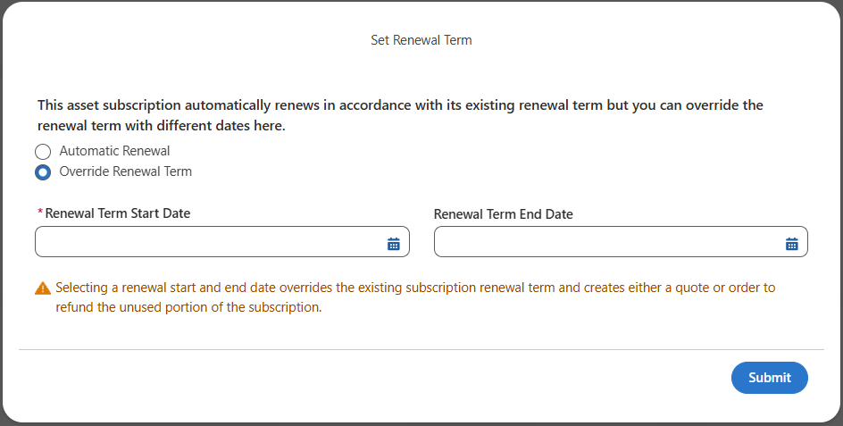

User Story # | User Story Details
RCA-286 | Renewals opportunity to be created with the same contract type as the original deal
Acceptance Criteria | As a RCA Admin,  I shall schedule the renewal opportunity creation process for the below contract types -  Subscription  Bulk $  Bulk Units  PerCert (PayGo)  PerCert (OnGo)  PerCert (Voucher)  Flat Fee  ELA  The above contract types shall be updated on the renewal quote created underneath the auto generated renewal opportunity.  As a sales rep,  I shall see the same contract type stamped on the renewals quote and opportunity, as stamped on the original new logo/expansion opportunity.  I shall not have any option to change the ‘Contract Type’ on auto generated renewal opportunities during the quote lifecycle.
Solution Summary | - After a new sales/new logo order is placed and activated, using the ootb flow “Create and Update Renewal Opportunities” system will create a renewal opportunity with opportunity products from new sale order.  - System should cascade the Contract Type from the new logo opportunity or previous renewal opportunity to the latest renewal opportunity. (The contract type on the new logo opportunity will be updated once a quotation created under the new logo opportunity is synced.)  - There should be a validation rule in place on the renewal quotations which are created out of renewal opportunities and throw an error message if sales rep tries to change the contract type.  - The validation to restrict changing contract type should apply to all the quotations whose Quote Type = ‘Renewals’.

User Story # | User Story Details
RCA-447 | Enable 'Browse Catalog' on renewal quotes
Acceptance Criteria | As a Sales Rep,  I shall be able to see the ‘Browse Catalog’ button on the renewals quote.  On clicking the ‘Browse Catalog’ option, I shall be able to view all the catalogs and respective products/SKU information based on the 'contract type' defaulted on the renewals quote (from the original opportunity/deal).  I shall be able to select respective products from the catalog, configure it and add them to the cart.
Solution Summary | - On the renewal quote whose Quote Type = ‘Renewals’ there should not be any restriction on the Browse Catalog button.  - Out of the Box system allows adding new products from the Browse Catalog on the Renewal quote.  - If the renewal quote is created from the renewal opportunity, the contract type on the quote will be defaulted. System shows the products in the Browse Catalog accordingly.  - The new product end date should be matched with the existing renewal product to coterm.

Security:

User Story # | User Story Details
RCA-335 | Field-level security
Acceptance Criteria | RCA Admin must be able to configure field-level visibility and edit permissions for each object (e.g., Quote, Order, Quote Line Item, Order Line Item).  Field-level access must be configurable based on user role, profile, or permission set.  Any changes made to field-level security must be audited in the RCA audit log with details of who made the change, when, and what was updated.  Users should only see or edit fields allowed for their assigned role/profile.
Solution Summary | Please find the below permissions sets and the related permissions as mentioned below:  Permission Set Access  RCA - Quote Provide edit access to all custom fields related to Quote, Quote LineItem(Anything related to Quote functionality)  RCA - View Quote Provide read access to all custom fields related to Quote, Quote LineItem(Anything related to Quote functionality)  RCA - Contract Provide edit access to all custom fields within objects that related to Contract functionality  RCA - View Contract Provide read access to all custom fields within objects that related to Contract functionality  RCA - Order Provide edit access to all custom fields within objects that related to Order functionality  RCA - View Order Provide read access to all custom fields within objects that related to Order functionality  RCA - Assets Provide edit access to all custom fields within objects that related to Assets  RCA - View Assets Provide read access to all custom fields within objects that related to Assets  RCA - System Admin Provide edit access to all custom fields which we created across all objects  RCA - System Read Only Provide Read access to all custom fields which we created across all objects

User Story # | User Story Details
RCA-342 | Audit log and field history tracking
Acceptance Criteria | Audit Log Tracking:  The system must automatically capture and record all RCA Admin activities related to transactional data objects(e.g., Quote, Approval Request, Contract, Order)  Each audit log entry must include the following details:  Timestamp of the action  RCA Admin username  Object/module impacted (e.g., Quote, Order)  Type of action performed (Create / Update / Delete / Enable / Disable)  Previous and new values for modified records (where applicable)  Audit logs must be read-only - no RCA Admin or user can alter or delete logged entries.  RCA Admin shall be able to enable the field tracking history for the required RCA objects as per additional requirements/compliance.
Solution Summary | - A Salesforce audit log, specifically the Setup Audit Trail, tracks changes made to your Salesforce organization's setup and metadata. It logs details like who made a change, what was changed, and when it occurred, which is useful for troubleshooting, security, and tracking modifications made by multiple administrators. The most recent 20 changes are visible in the interface, and you can download a history of changes for the past six months as a CSV file.  - Access the "View Setup Audit Trail" page in Salesforce Setup to see the 20 most recent entries.  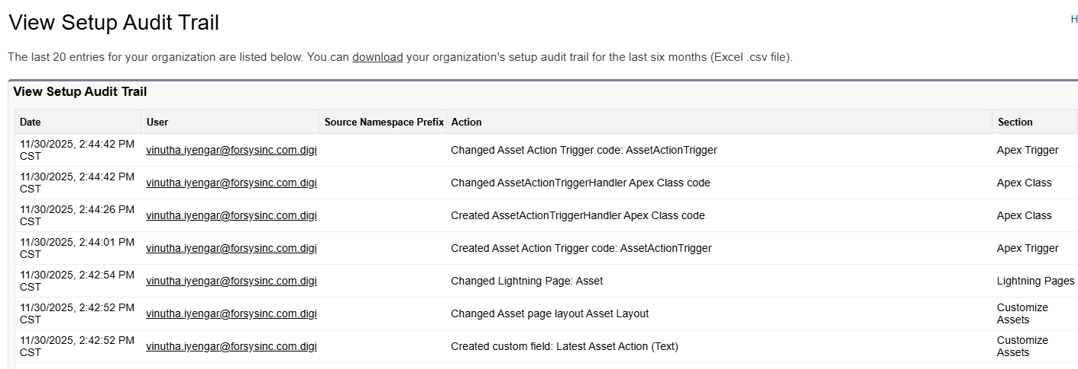  - A field history tracking can be enabled at object level under Fields and Relationships → Set History Tracking. Up to 20 fields are supported at each object level. Please follow the current history tracking in the current system for field information As Is Field Tracking.xlsx

User Story # | User Story Details
Acceptance Criteria
Solution Summary

Order Management

User Story # | User Story Details
RCA-328 | Add chevrons based on order status along with ownership details
Acceptance Criteria | The Order Detail page must display a chevron-style progress bar at the top, representing key order stages (e.g., Submitted to OM→ Order review and processing→ Activated)  The chevrons should visually indicate:  Current Stage: Highlighted or filled color.  Completed Stages: Marked as completed (e.g., with check icon or shaded color).  Upcoming Stages: Greyed out or inactive.  Each chevron stage corresponds directly to an Order Status value in Salesforce/RCA.  Changes in Order Status should automatically update the chevron display in real time.  Each stage (chevron) displays ownership details on the order.
Solution Summary | - Below are the list of order statuses provided by Digicert  - Submitted to OM  - Order review and processing  - Activated  - Outyear PO review  - Pending Sales resolution  - OM - CA loading/key ceremony  - OM - Validation  - OM - Pending 3rd party fulfillment  - CSM - DC1 fulfillment  - Canceled  - A chevron to be displayed on the order record using path settings with all the statuses.  - The change in order status will update the chevron and the current status will be highlighted. This is out of the box feature if path settings are configured.

User Story # | User Story Details
RCA-340 | Order Layout and Field Access
Acceptance Criteria | - As an RCA Admin, I should be able to configure the Order Layout in such a way that the Order Detail page is divided into logically grouped sections:  - Details  - Account, Contact & Address Information  - Additional Order Processing Information  - Customer Provisioning Form (PKI/DC1)  - Pricing Information  - PO Information  - Key Dates  - System Information  - Multi-year deals (PO received for each year)  - Each section contains only the fields relevant to that category.  - All sections should be visually separated and properly labeled.  - All mandatory fields are visible and editable as per user permissions.  - Non-editable (read-only) fields are visually differentiated from editable ones.
Solution Summary | - The order layout should be created in the RCA Order object with the same sections and fields that are available on the Apttus Orders layout.  - The field level access should be provided for the order fields to Sales Rep and Order Management team as per the current access provided on the Apttus Order object.

User Story # | User Story Details
RCA-375 | Process for marking an order as 'Problem Order' (before booking)
Acceptance Criteria | As an Order Management (OM) user, I want to mark an order as a Problem Order based on validations by updating the Order status as 'Pending Sales resolution'
Solution Summary

User Story # | User Story Details
RCA-383 | Process for marking an order as canceled (after booking)
Acceptance Criteria | - Once the Order is submitted to NetSuite and booked, if any changes are required, the Order should be cancelled in NetSuite, and the Order status in Salesforce RCA should be updated as Cancelled Order.  - As a Sales Rep, I shall be able to create a new Opportunity and create new Cancel and Replace type Quote under the same Opportunity to terminate the existing assets and create a new Order.
Solution Summary

User Story # | User Story Details
Acceptance Criteria
Solution Summary

User Story # | User Story Details
Acceptance Criteria
Solution Summary

User Story # | User Story Details
Acceptance Criteria
Solution Summary

User Story # | User Story Details
Acceptance Criteria
Solution Summary

User Story # | User Story Details
Acceptance Criteria
Solution Summary

User Story # | User Story Details
Acceptance Criteria
Solution Summary

User Story # | User Story Details
Acceptance Criteria
Solution Summary

User Story # | User Story Details
Acceptance Criteria
Solution Summary

User Story # | User Story Details
Acceptance Criteria
Solution Summary

User Story # | User Story Details
Acceptance Criteria
Solution Summary

User Story # | User Story Details
Acceptance Criteria
Solution Summary

User Story # | User Story Details
Acceptance Criteria
Solution Summary

User Story # | User Story Details
Acceptance Criteria
Solution Summary

User Story # | User Story Details
Acceptance Criteria
Solution Summary

User Story # | User Story Details
Acceptance Criteria
Solution Summary

User Story # | User Story Details
Acceptance Criteria
Solution Summary

User Story # | User Story Details
Acceptance Criteria
Solution Summary

User Story # | User Story Details
Acceptance Criteria
Solution Summary

User Story # | User Story Details
Acceptance Criteria
Solution Summary

User Story # | User Story Details
Acceptance Criteria
Solution Summary

User Story # | User Story Details
Acceptance Criteria
Solution Summary

User Story # | User Story Details
Acceptance Criteria
Solution Summary

